Quantum Physicist Shows How Consciousness Can Create Reality
In his argument against physicalism (physical nature is all there is), Andersen draws from the 19th-century philosopher Schopenhauer the concept of Will as the basis of all reality
_{News}
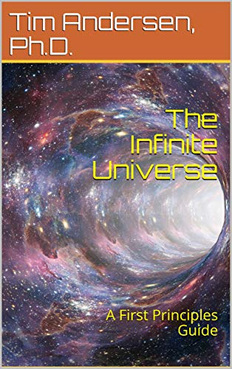
Tim Andersen, principal research scientist at Georgia Tech in general relativity and quantum field theory and author of The Infinite Universe: A First Principles Guide (2020), offers a riff on the philosopher Arthur Schopenhauer (1788–1860). He argues, with Schopenhauer, that Will is the basis of reality:
The key to understanding Will is in examining our own sense of consciousness. We have, in a sense, two levels of consciousness. The first is of experience. We experience a flower’s color and smell. Therefore, we are conscious of it. The second is that we are aware of our consciousness of it. That is a meta-consciousness which we sometimes call reflection. I reflect on my awareness of the flower. It is this second level of consciousness that gives rise to all art and poetry, for direct experience is simply awareness of a thing. Reflection on that experience internalizes awareness and makes it Representation.
Will is unconscious without Representation. Only through Representation does Will become conscious of itself. Likewise, only by measuring the quantum particles and reflecting on those do we become aware of the will we exerted upon the universe.
Tim Andersen, Ph.D., “Consciousness may create reality” at Medium (July 8, 2020)
Schopenhauer, according to the Internet Encyclopaedia of Philosophy, “was among the first 19th century philosophers to contend that at its core, the universe is not a rational place.” It is governed by Will, the direction in which things move. Anderson explains,
The difference between how nature experiences Will, however, and how it manifests in human beings comes down to reflection. Humans reflect on experience and then make plans, use knowledge, and employ reason. This reflection then creates more experience and volition. With nature, there is no reflection. Volition is always raw. So you have to extend what you understand volition to be.
Schopenhauer uses the example of a stone falling to Earth. There is a Will in the stone’s fall, but no reflection. The stone isn’t obeying some motive here. It is blindly following its Will. The stone experiences itself falling but cannot reflect upon it. It doesn’t know it is falling.
Tim Andersen, Ph.D., “Consciousness may create reality” at Medium (July 8, 2020)
Obviously, unlike stones, we can reflect on our experiences, learn things, and make decisions. That, says Andersen, includes physicists taking measurements of particles in detectors:
From a physics perspective, this argument is just the reverse interpretation of the standard superdeterminism argument that all our decisions are determined by some hidden states at the Big Bang. Rather, our decisions, emanating from underlying Will, determine those states. Our Will is essential and reality manifests around it.
This would be a universe that is, in a sense, constructed by the inhabitants that it manifests — a self-building universe created by consciousness. That may be a universal consciousness or it may not be. Whatever the truth is it is a powerful argument against physicalism.
Tim Andersen, Ph.D., “Consciousness may create reality” at Medium (July 8, 2020)
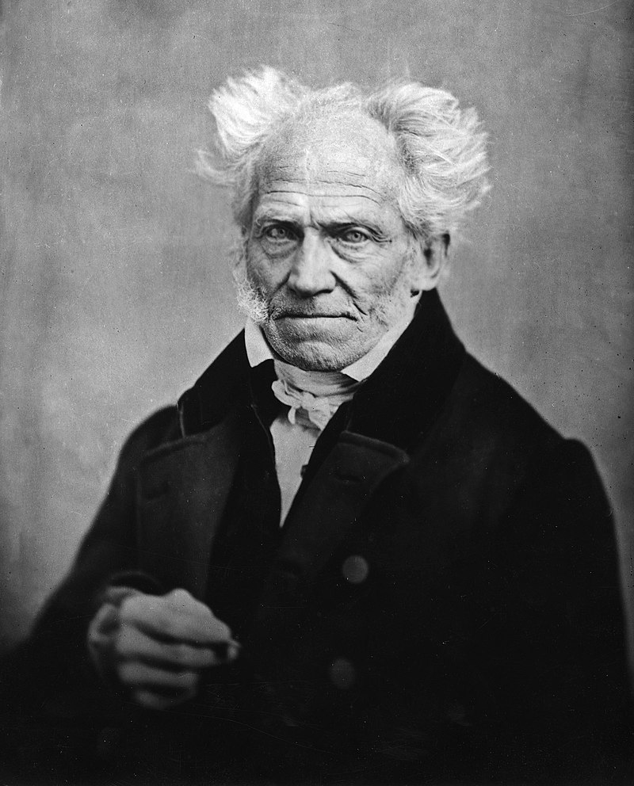Arthur Schopenhauer in 1859
Schopenhauer, in general rather a pessimist, is hardly to all tastes, for example: “It would be better if there were nothing. Since there is more pain than pleasure on earth, every satisfaction is only transitory, creating new desires and new distresses, and the agony of the devoured animal is always far greater than the pleasure of the devourer.”
In a review of Bryan Magee’s The Philosophy of Schopenhauer (1985), Roger Kimball notes that his concept of Will is not exactly encouraging:
An endless and ultimately purposeless striving, the will shows itself as much in the pull of gravity or the germination and growth of plants as in man. In most of the will’s manifestations, then, the question of “intentions” does not arise.
But Magee misses Schopenhauer’s point when he suggests that the term “force” or “energy” would have been preferable to the term “will.” Schopenhauer insists on calling the fundamental animating principle of the world “will” precisely because our understanding of the dynamic reality of nature is rooted in the immediate, intuitive grasp we have of our own dynamic reality as striving, wanting, lacking creatures, as creatures of will. Reading ourselves into nature, we extend the name of the reality we know best to the reality of the external world. “I therefore name the genus after its most important species,” Schopenhauer explains, “the direct knowledge of which lies nearest to us, and leads to the indirect knowledge of all the others.”
Roger Kimball, “Schopenhauer’s world” at New Criterion (April 1985)
In the piece at Medium, Andersen includes much more in in his argument against physicalism (physical nature is all there is).
While reflections on a universal Will or universal Mind (Bernardo Kastrup’s view) will seem far out to many, it’s helpful to realize that quantum mechanics, among other things, has made simple materialism, including physicalism, increasingly untenable. So curious minds look at alternatives. And Schopenhauer, a very influential philosopher in his day, was bound to come up, even if Will appears to many of us to be an inadequate substitute for mind.

