# El Salvador’s Strongman Is Set to Ride a Landslide Past Checks and Balances

The millennial president, Nayib Bukele, and his party are likely to win resoundingly in elections Sunday. His running mate says they are “replacing” democracy.

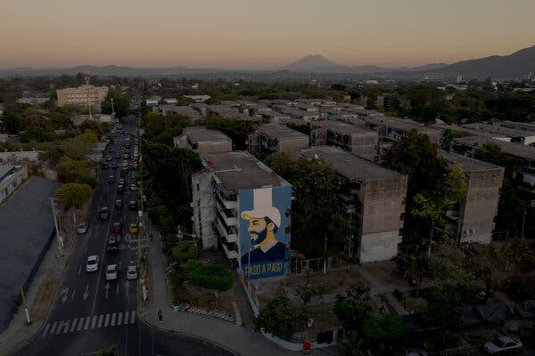

President Nayib Bukele’s face adorns an apartment building in the Zacamil neighborhood of San Salvador. The Barrio 18 street gang controlled the neighborhood for decades until its members were arrested under Mr. Bukele’s crackdown.

By Natalie Kitroeff

Feb. 2, 2024

El Salvador’s government has jailed thousands of innocent people, suspended key civil liberties indefinitely and flooded the streets with soldiers. Now the president overseeing it all, Nayib Bukele, is being accused of violating the constitution by seeking re-election.

And even his vice-presidential running mate admits their goal is “eliminating” what he sees as the broken democracy of the past.

But [polls show most Salvadorans](https://www.disruptiva.media/wp-content/uploads/2024/01/vi-estudio-de-humor-social-2.pdf) support Mr. Bukele, often not in spite of his strongman tactics — but because of them.

In elections on Sunday, voters are expected to hand Mr. Bukele and his New Ideas party a resounding victory, cementing the millennial president’s control over every branch of government.

The biggest reason, analysts say, is that the 42-year-old leader has achieved a seemingly impossible feat: decimating the vicious gangs that had turned El Salvador into one of the world’s most violent places.

“Some people call it a dictatorship,” said Sebastián Morales Rivera, a fisherman living in a former gang stronghold. “But I would prefer to live under the dictatorship of a man with a sound mind than under the dictatorship of a bunch of psychopathic maniacs.”

For more than two decades, warring gangs terrorized El Salvador, stifling the economy, killing civilians at will and prompting a wave of migration to the United States.

The two parties that governed the country did little to control the bloodshed, elevating presidents who enriched themselves while leaving their fellow Salvadorans to be hunted like prey by criminals.

Mr. Bukele, a backward-hat-wearing millennial promising change, was swept [into office](https://www.nytimes.com/2019/02/03/world/americas/salvador-bukele-election.html) in 2019 by voters disgusted with the political establishment. And while the crackdown that followed has restricted freedoms, it also delivered the results that so many had craved.

Félix Ulloa is running for re-election as vice president alongside Mr. Bukele.

“To these people who say democracy is being dismantled, my answer is yes — we are not dismantling it, we are eliminating it, we are replacing it with something new,” said Félix Ulloa, who is running for re-election as vice president alongside Mr. Bukele.

The democratic system that existed for years in El Salvador, Mr. Ulloa said, only benefited crooked politicians and left the country with tens of thousands murdered. “It was rotten, it was corrupt, it was bloody,” he said.

With a triumph at the polls on Sunday, Mr. Bukele would join a class of global leaders winning repeated elections even as they are accused of chipping away at the foundations of democratic rule.

The leaders of India, Turkey and Hungary, for example, have all earned multiple terms at the polls while being accused of authoritarian tendencies. In the United States, Donald J. Trump is closing in on the Republican nomination for president while facing criminal prosecution for mounting an insurrection.

With every victory, analysts say, these charismatic strongmen are forcing their countries to reckon with an increasingly urgent question: How much does the system of checks and balances once considered a bedrock of liberal society actually matter to voters?

A protest in San Salvador to demand the release of relatives detained during the state of emergency.

Nowhere is that being asked more openly than in El Salvador, where Mr. Bukele enjoys the backing of around 80 percent of the population, [surveys show](https://drive.google.com/file/d/13ysrVXBUlobHAiDnkSC3tac8IGR6-JCa/view), and many seem happy to give him absolute dominion over the country if it guarantees them safety.

Mr. Bukele “needs control over everyone because not everyone has his mind,” Mr. Morales said. “I would re-elect him three times if necessary.”

El Salvador’s constitution bans presidents from seeking a consecutive term, according to legal scholars. But in 2021, Mr. Bukele’s party, which has a supermajority in Congress, replaced the top judges on the Supreme Court — who then reinterpreted the constitution to allow him to run again.

“This is no longer a constitutional republic,” said Noah Bullock, executive director of Cristosal, a Salvadoran human rights group. “It’s a de facto authoritarian regime.”

Some human rights defenders wonder whether Mr. Bukele might find a way to stay in office for the long haul. Mr. Bukele said on Twitter Spaces that he was not seeking “indefinite re-election,” noting that “the current norms don’t permit it.”

The Barrio 18 street gang controlled the Montes de San Bartolo 5 neighborhood in Soyapango, a municipality just outside San Salvador, for decades before the crackdown.

But Mr. Ulloa said the vast majority of the country actually wants Mr. Bukele to be president “for life.”

After an explosion of violence in the spring of 2022, the government imposed a state of emergency and launched a campaign of mass arrests with no due process.

Some 75,000 people have been jailed, including 7,000 who were eventually released and thousands of others who aren’t gang members but remain behind bars, according to human rights groups. The government built a mega prison to house them all.

Cristosal and Human Rights Watch [reported that inmates were being tortured](https://www.hrw.org/report/2022/12/07/we-can-arrest-anyone-we-want/widespread-human-rights-violations-under-el) and deprived of food. Their fates were decided in mass trials with judges whose identities were kept secret. “Those are crimes against humanity,” Mr. Bullock said.

But the state of emergency, which has lasted almost two years, transformed the country. Killings plunged. Extortion payments have reportedly dropped.

Apprehensions of Salvadorans crossing the U.S. border dropped by about a third during last fiscal year — when migration overall soared — a decline experts attribute in part to the new sense of security on the streets.

Irma Mancía de Olmedo’s son, Mario, has been detained for nearly two years.

Many would consider Irma Mancía de Olmedo a victim of the new police state.

Her son, Mario Olmedo Mancía, was arrested by the authorities on a Friday morning, in April 2022, when he left home to get a hair cut. His family has not heard from him since.

“I don’t know how he’s doing, nothing,” said Ms. Mancía de Olmedo, sobbing.

Ms. Mancía de Olmedo says Mario wasn’t involved in gangs and has documents showing he worked in a call center.

But even in her grief, the 56-year-old has nothing but admiration for Mr. Bukele.

“He has done everything possible to make the country better,” she said. “If some of us are suffering the consequences, well, these things happen.”

For years, Ms. Mancía de Olmedo had never dared to visit her aging mother, who lived in a neighborhood controlled by the MS-13 gang. Now she goes there regularly.

There are still pockets of resistance to Mr. Bukele, particularly among families who say their relatives were unjustly imprisoned. And questions remain about whether the government is really committed to going after gang leaders.

American officials say that before the crackdown, Mr. Bukele’s administration negotiated with gang leaders for a reduction in homicides in exchange for benefits in prison. Top Salvadoran officials, [the Department of Justice says,](https://www.justice.gov/usao-edny/pr/high-ranking-ms-13-fugitive-arrested-terrorism-indictment) helped an MS-13 boss escape the country, even though the United States had requested his extradition.

A resident of San Salvador takes a calendar with photographs of Mr. Bukele during campaigning by political workers.

Mr. Bukele has denied making a deal with gangs, and the charge has had no discernible impact on his enormous popularity.

A former publicist, Mr. Bukele doesn’t spend much time touring the country or holding rallies — he is a star on Facebook, TikTok, and X, where his messages reach millions.

Most Salvadorans think Congress should not stand in Mr. Bukele’s way, because he alone can fix the country’s problems, according to research by the University Institute for Public Opinion, at the José Simeón Cañas Central American University.

“His charisma has been determinative not just in how the population evaluates him, but in how they interpret the reality of the country,” said Laura Andrade, the institute’s director.

Mr. Bukele is selling himself as “a messianic figure, a savior figure who is rescuing a people who had been violated by other leaders,” she said.

It’s not just Salvadorans that are buying the pitch. Mr. Bukele has earned admirers across the Western Hemisphere, especially in violent countries like Ecuador, [where the recently elected president has promised](https://www.nytimes.com/2024/01/10/world/americas/ecuador-violence-gangs-prison.html) to build prisons just like Mr. Bukele’s.

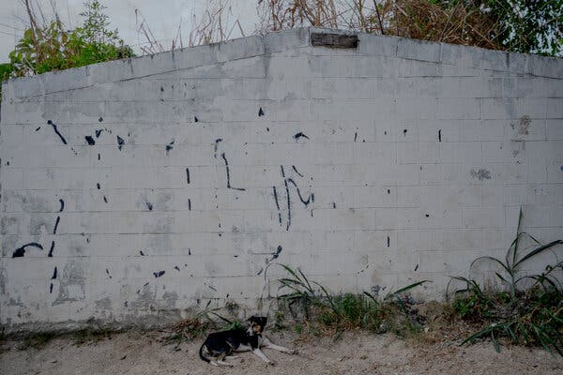

Gang graffiti covered with white paint in the La Campanera neighborhood in Soyapango.

El Salvador’s opposition is in tatters, and its five candidates barely register in the polls. The ruling New Ideas party’s campaign, meanwhile, consists mainly of promising people more of Mr. Bukele and stoking fear of losing everything he gave them.

The threat has worked. Many who live in neighborhoods that were once war zones say they believe that putting anyone other than Mr. Bukele in charge could risk their safety.

“They’ll free the prisoners,” said Mr. Morales. “All politicians are manipulatable.”