# Taiwan’s Democracy Draws Envy and Tears for Visiting Chinese

People with personal ties to China, on a tour to see Taiwan’s election up close, learned of the island’s path to democracy — messy, violent and, ultimately, inspiring.



By Li Yuan

January 19, 2024

At the Taipei train station, a Chinese human rights activist named Cuicui watched with envy as six young Taiwanese politicians campaigned for the city’s legislative seats. A decade ago, they had been involved in parallel democratic protest movements — she in China, and the politicians on the opposite side of the Taiwan Strait.

“We came of age as activists around the same time. Now they’re running as legislators while my peers and I are in exile,” said Cuicui, who fled China for Southeast Asia last year over security concerns.

Cuicui was one in a group of eight women I followed last week in Taiwan before the Jan. 13 [election](https://www.nytimes.com/2024/01/13/world/asia/taiwan-election-china-us.html). Their tour was called “Details of a Democracy” and was put together by Annie Jieping Zhang, a mainland-born journalist who worked in Hong Kong for two decades before moving to Taiwan during the pandemic. Her goal is to help mainland Chinese see Taiwan’s election firsthand.

The women went to election rallies and talked to politicians and voters, as well as homeless people and other disadvantaged groups. They attended a stand-up comedy show by a man from China, now living in Taiwan, whose humor addressed topics that are taboo in his home country.

It was an emotional trip filled with envy, admiration, tears and revelations.

The group made several stops at sites that demonstrated the “[White Terror](https://www.nytimes.com/2016/02/04/world/asia/taiwan-white-terror-executions.html)” repression Taiwan went through between 1947 and 1987, when tens of thousands of people were imprisoned and at least 1,000 were executed after being accused of spying for China. They visited a former prison that had jailed political prisoners. For them, it was a history lesson in Taiwan’s journey from authoritarianism to democracy, a path they believe is increasingly unattainable in China.

“Although it may seem like traveling backward in time for people in Taiwan, for us, it’s the present,” said Yamei, a Chinese journalist in her 20s now living outside China.

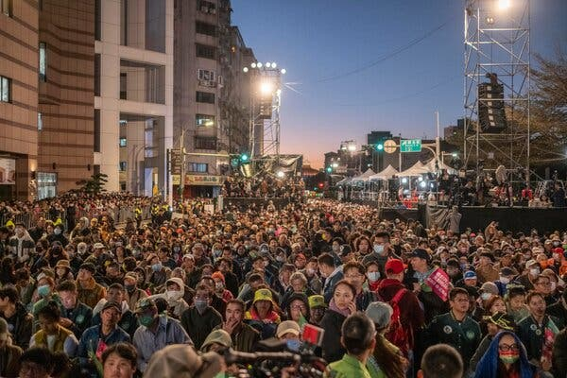

Supporters at a campaign event in Taipei for Lai Ching-te on Election Day.

Members of the group flew in from Japan, Southeast Asia and the United States — anywhere but China. Both China and Taiwan have made it harder for Chinese to visit the island as tensions between them have spiked over Beijing’s increasingly assertive claim on the island. They ranged in age from their 20s to their 70s. Some were activists like Cuicui, who left the country recently, while others were professionals and businesspeople who have lived abroad for years and are not necessarily political in their outlook.

Angela Chen, a real estate agent in Portland, Ore., joined the tour to take her mother on a vacation. Ms. Chen is a naturalized U.S. citizen who identifies culturally as Chinese. The trip was eye opening, she said. She was shocked to learn how tragic and fierce Taiwan’s democratization process had been. Her father, like many Chinese parents, told her not to get involved in politics. Now she felt that everyone had to contribute to push a society forward.

Until a decade ago, visiting Taiwan to witness its elections was a popular activity for mainland Chinese who were interested in exploring the possibilities of democratization.

It’s easy to see why. Most Taiwanese speak Mandarin and share a cultural heritage with China as Han Chinese. As mainlanders searched for an alternative Chinese society, they naturally turned to Taiwan for answers.

I traveled to Taiwan in 2012 to report about such a group, which had more than a dozen top Chinese intellectuals, entrepreneurs and investors. At the time, debates about the pros and cons of democracy, republicanism and constitutionalism were common on Chinese social media.

Opinion leaders were asking whether China would ever have a leader like Chiang Ching-kuo, the Taiwanese president who gradually shifted away from the dictatorial rule of his father, Chiang Kai-shek, in the 1980s.

That seems like a lifetime ago. Soon after that, Xi Jinping took over as China’s leader, and he has moved the country in the opposite direction. Civil society has been pushed underground and discussions about democracy forbidden.

Last week’s group visited Taiwan under very different circumstances. Most of them wanted to remain anonymous, agreeing to talk to me only if I identified them by their first name, because merely cheering Taiwan’s democracy is politically sensitive.

At [Jing-Mei White Terror Memorial Park](https://www.nytimes.com/2022/10/25/world/asia/taiwan-china-pelosi.html), the former prison, it was easy for the group to picture how people had spent their time in crowded, humid and shabby cells and washed their clothes in toilets.

“Many people thought that Taiwan’s democracy fell from the sky,” Antonio Chiang, a former journalist, dissident and adviser to the departing president, Tsai Ing-wen, told the group over lunch after their visit to the jail site. “It was the result of many people’s efforts,” he said.

Mr. Chiang added, “It will be a very long time before China becomes a democracy.”

Everyone knew that was true. Still, it was deflating for them to hear. But their despair didn’t last long.

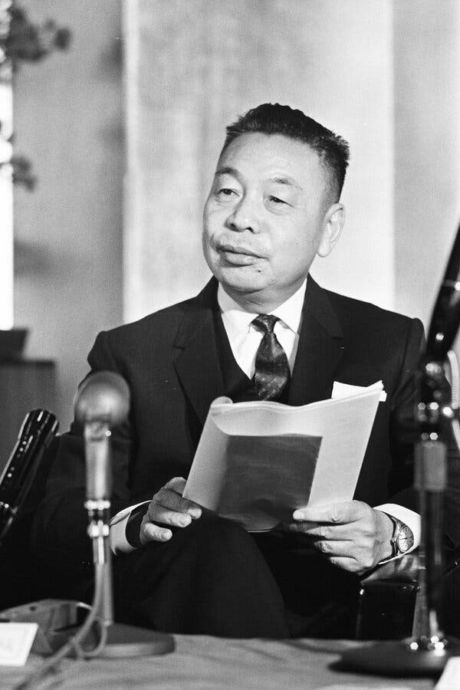

Chiang Ching-kuo, the president who gradually shifted Taiwan away from dictatorial rule, at a news conference in Tokyo in 1967.

They heard from the daughter of Cheng Nan-jung, a publisher and pro-democracy activist who set himself on fire to protest the lack of freedom of speech in 1989. At the site of his self-immolation, her comments resonated with the visiting Chinese: “The predicament of a country can only be resolved by the people of that country themselves.”

Then they went to the stand-up show by the comic, who was from Xinjiang, the western Chinese region where more than one million Muslims were sent to re-education centers. Everyone cried. It was both heartbreaking and cathartic for them to hear someone using words, such as “Uyghurs,” “re-education camps” and “lockdowns,” that are considered too sensitive to be discussed at a public venue in China.

“If everyone does what they can, does it well and with a little more courage, our society will become better,” said the comic, who asked not to be named.

For the group, the most empowering part of the tour was to witness the citizens organizing themselves and casting their votes. As the visitors gathered at the island’s presidential palace, Yamei, the journalist, was surprised that its entrance was painted peachy pink.

“It was not an institution surrounded by absolute solemnity or high walls that would intimidate you,” she said. The contrast with Zhongnanhai, the compound for China’s top leaders in Beijing, “was quite striking.”

After watching a documentary about bar hostesses who had organized a union, they learned that the women had drafted legislation to protect their rights. That would be unimaginable for anyone in China.

While homeless people are largely invisible in Chinese cities — because the authorities won’t allow them to be visible — the group learned that many organizations in Taiwan provide homeless people with meals, places to shower and other support.

At election rallies, they saw voters — young and old, and parents with strollers — pack squares and stadiums to listen to candidates make their pitches.

In the days before the election, they had heard from many Taiwanese who had still not decided which of the three presidential candidates they would vote for. Yet, the turnout on Taiwan’s [Election Day was 72 percent](https://www.nytimes.com/2024/01/13/world/asia/taiwan-election-china-us.html), higher than the 66 percent that came out in the U.S. presidential election in 2020, the [highest](https://www.pewresearch.org/politics/2023/07/12/voter-turnout-2018-2022/) turnout in an American vote since 1900.

The candidate of the ruling Democratic Progressive Party, [Lai Ching-te](https://www.nytimes.com/2024/01/14/world/asia/taiwan-election-lai.html), won with 40 percent of the vote — not a satisfying outcome even for some of the party’s supporters. But still the people chose who would be their leader.

At a rally in the southern city of Tainan, amid the sounds of drums, gongs and fireworks, Lin Lizhen, the owner of a jewelry store, told the tour group proudly, “This is democracy.”

Then she said: “I know the mainlanders like freedom, too. They just don’t have the power to fight back.”