Opinion

Poland is a test case for reviving a corrupted democracy
January 18, 2024
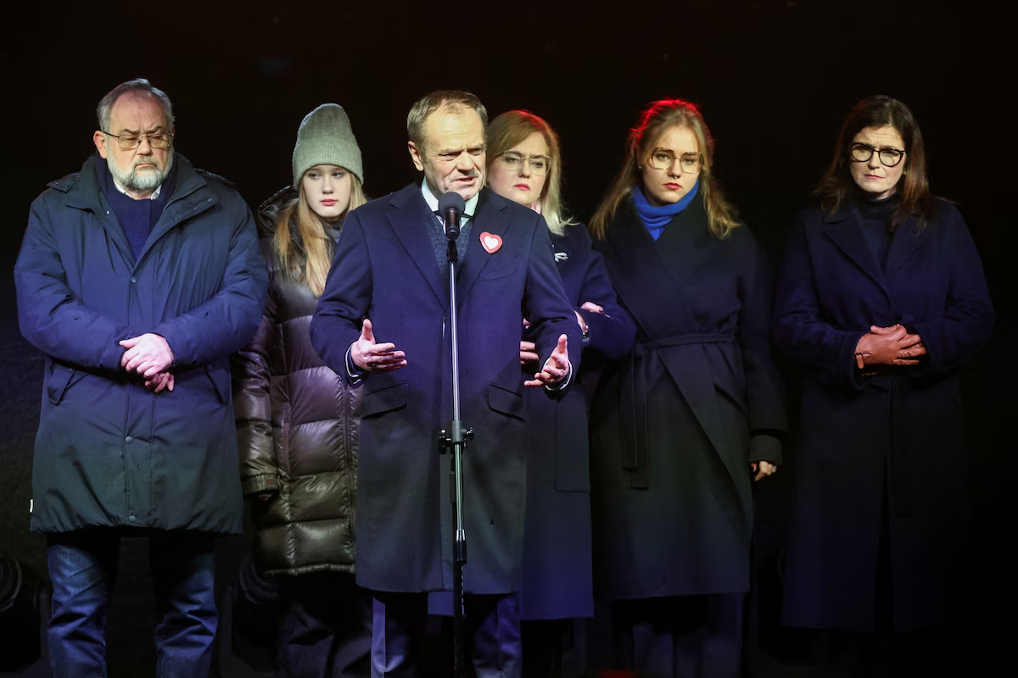
Polish Prime Minister Donald Tusk speaks in Gdansk on Jan. 13.
PARIS — With authoritarians and tyrants on the march across the world, Poland is an emerging test case of whether a corrupted democracy can be revived. The discouraging early signs are that it might be harder than building one from scratch.
Contempt for the niceties of representative and pluralistic democracy, along with florid rhetorical excess, were the trademarks of the man who controlled Poland’s ruling party for the past eight years, before a shock electoral defeat last fall cast him into political exile.
Now Jaroslaw Kaczynski, having meted out death by a thousand cuts to Polish democracy in a failed effort to cement his grip on power, leads an irreconcilable opposition.
His escalating standoff with the new government of Prime Minister Donald Tusk is a stress test that is likely to subject Eastern Europe’s biggest and most influential country to a bitter contest of wills for the foreseeable future. And it is far from clear that Poland can regain the vibrant democracy, independent judiciary and robust institutions it worked so hard to establish from the ruins of communism more than 30 years ago.
“It was easier then because there was broad consensus in society and the political class about the general direction,” Piotr Buras, head of the European Council on Foreign Relations’ Warsaw office, told me. “Now this is the core of the conflict.”
Tusk, who was prime minister from 2007 to 2014, took office again last month. It doesn’t mean that he took power.
Over the course of its two terms in government, Kaczynski’s Law and Justice party jury-rigged systems, rules and institutions to its own partisan advantage, seeding its allies in the courts, prosecutors’ offices, state-owned media and central bank. Kaczynski’s administration erected an intricate legal obstacle course designed to leave the party with a stranglehold on key levers of power even if it were ousted in elections.
On top of that, President Andrzej Duda, a Kaczynski ally, is set to remain in office until his term expires in August next year. He retains broad powers, including to veto legislation, and has already thwarted Tusk’s agenda where possible.
A lot rides on Tusk’s success. For Poles, that includes not just their country’s status as a nation aligned with European values but also tens of billions of dollars in aid frozen by the European Union in response to the Kaczynski regime’s contempt for democratic norms, especially its partisan takeover of the judiciary.
The stakes are at least as high for the Western alliance. If there is consensus on anything in Poland, it is that the country’s own security, along with Europe’s, faces a mortal threat from Vladimir Putin’s Russia. And Warsaw has been a linchpin in the West’s lifeline to Ukraine, serving as one of Kyiv’s most stalwart allies, as well as the transshipment point for U.S. weapons bound for Ukrainian forces.
Yet nothing could please Putin more than to watch the creeping destabilization of Poland, a strategically vital member of the Western alliance whose borders with Russia itself and Belarus, a Russian satellite, are among Europe’s most dangerous flash points.
And along with faltering support for funding Ukraine in Washington and Europe, few developments would pose a greater threat to the bloc that President Biden and key European leaders have built to oppose the Russian dictator’s brutal attempt to establish a neo-Soviet empire, starting by subjugating Ukraine.
It’s too early to predict that Poland will come unraveled — that its current impasse will yield to anarchy or violence. But the signs are ominous.
Tusk rightly regards his agenda as an attempt to reassert not only democratic norms and institutions but justice itself. He is fighting simultaneously to rid the pernicious influence of Law and Justice from institutions insidiously politicized under the previous regime.
He has been challenged by judges loyal to Law and Justice, who make up about 20 percent of the judiciary, and by Duda, wielding his presidential powers. The result is an intensifying contest over who exercises the most basic powers of government in Poland, stoked by Kaczynski’s customary hyperbole. The new government, he told a rally of his party faithful, plans to “liquidate our homeland as a state.”
Tusk sees clearly what he faces — an attempt by Kaczynski’s forces to build “a dual power” by retaining control over key institutions, as he told a recent news conference. Critically, a plurality of Poles back him. In a poll this month, 47 percent of respondents said they expect Tusk will improve Polish democracy; just 28 percent believe he will damage it.
Larry Diamond, a Stanford professor who has written widely on the rise of autocrats and tyrants, has warned of the dire consequences of what he calls the world’s “democratic recession.” Poland can be a template for how to turn the tide of that recession.

