Opinion

The Founders’ antidote to demagoguery is a lesson for today

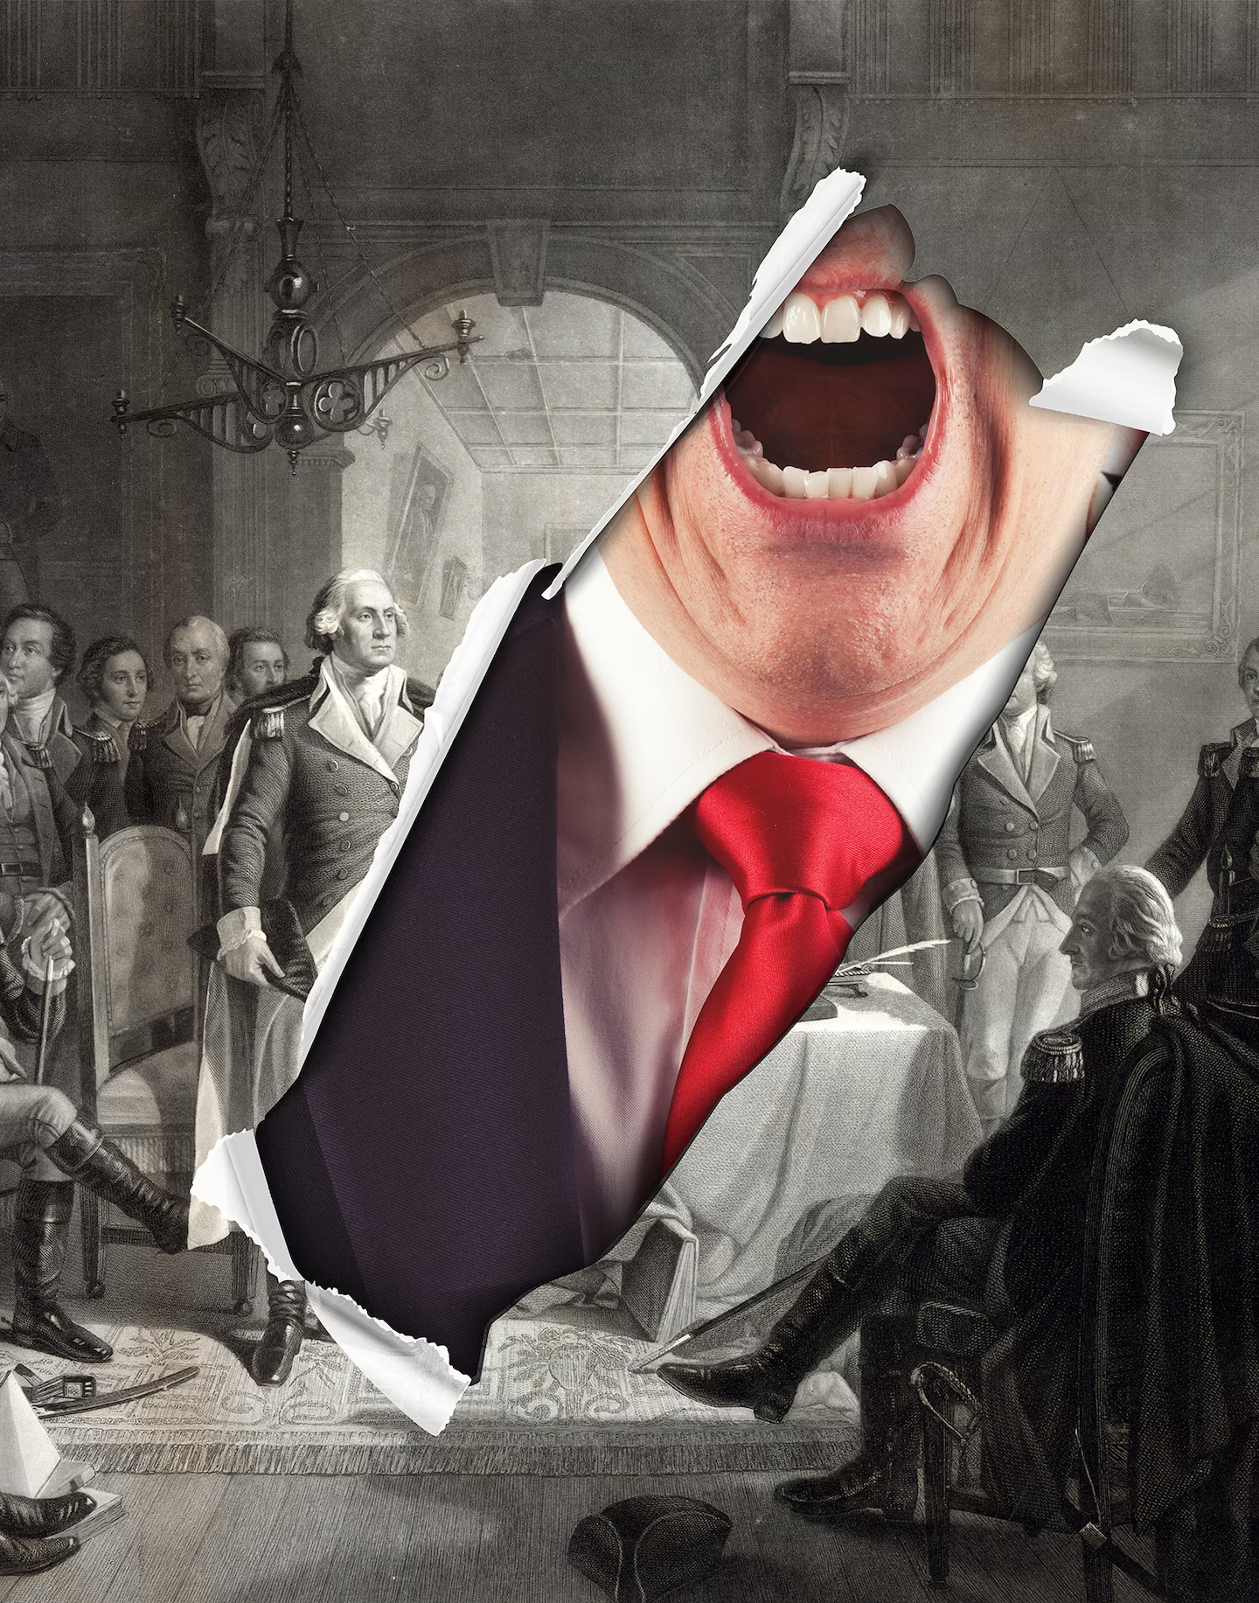
By Jeffrey Rosen
Jeffrey Rosen is president and chief executive of the National Constitution Center and author, most recently, of “The Pursuit of Happiness: How Classical Writers on Virtue Inspired the Lives of the Founders and Defined America.”
February 20, 2024
If the Founding Fathers were alive today, they would tremble for the future of our republic.
Watching the rise of hyper partisanship and populist demagogues in the United States and around the world would be their worst nightmare. And they would wonder: Can the citizens of today muster the personal and political virtue necessary to save our nation?
When they drafted the Constitution, the Founders’ greatest fear was that a populist demagogue would flatter the mob, subvert American democracy and establish authoritarian rule. “The only path to a subversion of the republican system of the Country is, by flattering the prejudices of the people, and exciting their jealousies and apprehensions, to throw affairs into confusion, and bring on civil commotion,” Alexander Hamilton wrote to George Washington in 1792. “When a man unprincipled in private life[,] desperate in his fortune, bold in his temper … is seen to mount the hobby horse of popularity … It may justly be suspected that his object is to throw things into confusion that he may ‘ride the storm and direct the whirlwind.’”
Thomas Jefferson agreed with Hamilton about very little, except for the danger of populist demagogues. After he read a draft of the Constitution, his main concern was that an unscrupulous candidate in the distant future might lose an election and refuse to leave office. “If once elected, and at a second or third election outvoted by one or two votes, he will pretend false votes, foul play, hold possession of the reins of government, be supported by the States voting for him,” Jefferson wrote to James Madison in 1787.
In the Founders’ view, the only thing standing between America and an authoritarian demagogue was the virtuous self-control of citizens who would find the wisdom to choose virtuous leaders. “I go on this great republican principle, that the people will have virtue and intelligence to select men of virtue and wisdom,” Madison said at the Constitutional Convention. “Is there no virtue among us? If there be not, we are in a wretched situation. No theoretical checks — no form of government can render us secure.”
When the Founders talked about the need for virtuous citizens and leaders, they were referring to the four classical virtues: prudence, temperance, fortitude and justice. (By contrast, the three theological virtues are faith, hope and charity.) Following the classical and Enlightenment moral philosophers, the Founders believed that personal self-government was necessary for political self-government. In their view, the key to a healthy republic begins with how we address our own flaws and commit to becoming better citizens over time.
In the Federalist Papers, Madison and Hamilton made clear that the Constitution was designed to foster deliberation so that citizens could avoid retreating into the angry mobs and partisan factions that demagogues can inflame. Ancient Athens had fallen because the demagogue Cleon had seduced the Athenian assembly into continuing the war with the Peloponnesian League; the Roman Republic had fallen because the people were corrupted by Caesar, who offered them luxury in exchange for liberty. Only by governing their selfish emotions as individuals could citizens avoid degenerating into selfish factions that threaten the common good.
The Founders believed that virtuous self-mastery was necessary for both personal and political happiness. Today, we think of happiness as the pursuit of pleasure. But classical and Enlightenment thinkers defined happiness as the pursuit of virtue — as being good rather than feeling good. Just as individuals can use their powers of reason to achieve psychological happiness, so can groups of citizens use theirs to achieve political happiness.
Washington made the connection between public and private virtue and happiness repeatedly in his career. “Virtue or morality is a necessary spring of popular government,” he warned in his Farewell Address. In his Circular to the States in 1783, he said that four things were necessary for the people’s political and social happiness: an “indissoluble Union,” a “sacred regard to public Justice,” a “proper Peace Establishment,” and the cultivation of private virtue, which he defined as “the prevalence of that pacific and friendly disposition among the people of the United States, which will induce them to forget their local prejudices and policies” and “to sacrifice their individual advantages to the interest of the community.”
At the end of their lives, the Founders disagreed about whether the American people would find the virtuous self-mastery to elect presidents who would sustain the republic. Jefferson, always more optimistic about American democracy, was more confident that the public mind could be calmed and perfected by education. “No government can continue good but under the control of the people,” Jefferson wrote to John Adams in 1819. “Their minds were to be informed, by education, what is right & what wrong, to be encouraged in habits of virtue.” Adams doubted that virtue could be taught on a wide scale. “Have you ever found in history one single example of a nation thoroughly Corrupted — that was afterwards restored to Virtue?” he replied to Jefferson.
Madison, as always, took the middle ground regarding the possibility of educating citizens in the habits of virtuous self-restraint. He put particular faith in a class of enlightened journalists and public officials, whom he called the literati. They could serve as moral educators, using new forms of media such as the broadside newspaper to calm and elevate the public mind. As Madison put it in a crucial passage in his “Notes for the National Gazette Essays”: “The class of literati is not less necessary than any other. They are the cultivators of the human mind — the manufacturers of useful knowledge — the agents of the commerce of ideas — the censors of public manners — the teachers of the arts of life and the means of happiness.”
Today, of course, the idea that new media might be deployed by an enlightened class of literati to refine public opinion seems quaint. In the age of social media, with its “enrage to engage” model, the opposite occurs. The passions, hyper partisanship and split-second decision-making that Madison and Hamilton feared from large groups meeting face to face have proved to be even more dangerous from exponentially larger groups that meet online.
It remains to be seen whether Americans today can find the virtuous self-restraint to put the public interest before the angry partisanship the Founders most feared. What’s clear, however, is that nothing less than the future of the Republic is at stake. As Madison wrote in Federalist 57: “The aim of every political Constitution is or ought to be first to obtain for rulers, men who possess most wisdom to discern, and most virtue to pursue the common good of the society; and in the next place, to take the most effectual precautions for keeping them virtuous, whilst they continue to hold their public trust.”

