Does Democracy Have a Future?
The future of democracy is a topic of significant debate and analysis. Various perspectives shed light on the challenges and potential outcomes for democratic systems globally. The New Yorker highlights the crisis in American democracy, emphasizing dysfunctional government institutions, electoral flaws, media influence, acrimonious politics, and societal shifts.

Despite these challenges, there is a determination among institutions, movements, thinkers, and citizens to strengthen democracy. IWM Website discusses the uncertainty surrounding modern democracy's ability to adapt to rapid global changes.

While acknowledging the positive long-term prognosis for democracy if political will is maintained, it also raises concerns about economic inequality, fundamentalism, and urbanization affecting democratic systems. Stanford News focuses on the concept of the civic bargain as essential for democracy's future.

This civic bargain involves deal-making and compromises among citizens to facilitate collective self-governance. The article emphasizes the importance of diverse information and well-motivated citizens in strengthening democracy. Thomas Carothers' work questions the future of democracy promotion and its challenges amidst global uncertainties.

The field of democracy promotion faces turbulence and controversy, with debates on its effectiveness and relevance in today's world. The Journal of Democracy presents a more optimistic view, suggesting that modernization theory supports a brighter future for democracy due to increasing knowledge, awareness, and commitment to emancipative values among citizens.

Despite current challenges and authoritarian surges, the long-term trend indicates a positive trajectory for democracy globally. In conclusion, while democracy faces significant hurdles such as political polarization, economic disparities, and global shifts, there are ongoing efforts to strengthen democratic systems through civic engagement, political will, and adaptability to changing circumstances. The future of democracy remains a dynamic and evolving landscape influenced by various factors at play globally.

What Challenges Are Facing Democracy in the Future?
Democracy faces a myriad of challenges that could impact its future trajectory. These challenges encompass various aspects such as economic inequality, authoritarianism, and societal dynamics.

Economic Insecurity and Inequality
Economic well-being plays a crucial role in the survival of democratic regimes. Historically, democracies have thrived when citizens' per capita income remains above a certain threshold, with exceptions like India. Economic inequality also poses a threat to democracy, as high levels of inequality can lead to extremism, undermining democratic processes.

Authoritarianism and Rising Extremism

The rise of authoritarian leaders globally presents a significant challenge to democracy. Leaders in countries like Russia and China are promoting authoritarian regimes as more efficient alternatives to democracy. This trend is coupled with increasing support for exclusionary ethnic politics and diminishing competition between political parties, which can erode democratic principles.

Institutional Crises and Loss of Trust

In countries like the United States, institutional crises, political polarization, and a loss of trust in government institutions are accelerating the disintegration of democracy. Issues such as voting restrictions, election fraud, and political polarization intensify the challenges faced by democratic systems. The erosion of trust in democratic processes can lead to disillusionment among citizens and weaken the foundation of democracy.

Global Dynamics and Changing Societal Norms

The rapid pace of global changes, including technological advancements, economic shifts, and societal transformations, poses challenges for modern democracies. The ability of democratic systems to adapt to these changes and address emerging issues such as urbanization, fundamentalism, and global inequalities will determine their resilience in the face of evolving circumstances.

In conclusion, the future of democracy is at a crossroads, facing multifaceted challenges that require proactive measures to safeguard its core principles. Addressing economic disparities, countering authoritarian influences, rebuilding trust in institutions, and adapting to changing global dynamics are essential steps to ensure the longevity and effectiveness of democratic systems worldwide.

What Are Some Potential Solutions to the Challenges Facing Democracy?
Addressing the challenges confronting democracy requires proactive measures and innovative solutions to safeguard its principles and functionality. Here are some potential solutions based on the provided search results:
- Boosting Democratic Engagement
Enhancing democratic engagement among citizens is crucial to mitigate threats to democracy. Measures such as providing information, education, communication, consultation, and participation can help increase citizen involvement in political decision-making processes. Initiatives like question-and-answer radio programs and educational programs for students can foster a sense of representation and accountability.

- Leveraging Technology Responsibly

Technology plays a significant role in shaping democratic processes. To counter the dissemination of fake news and polarization driven by technology, parliamentarians can promote engagement, accelerate digitization, strengthen youth inclusion, pursue gender parity, and address climate crises through digital strategies. Utilizing technology positively can enhance democratic practices and transparency.

3. Encouraging Youth Participation

Incorporating young people into political processes is vital for the progression of democratization. Measures like decreasing the age of eligibility for office and reserving seats for young individuals in parliaments can bridge the representation gap and empower future leaders to actively participate in governance. Ensuring youth involvement strengthens democratic systems for the long term.

4. Promoting Gender Balance

Achieving gender balance in political representation is essential for inclusive democracies. Efforts to increase female participation in parliaments through targeted policies and initiatives can address gender disparities in political leadership. Continuously striving to improve female representation enhances the diversity and effectiveness of democratic institutions.

5. Embracing Civic Education and Public Discourse

Promoting civic education, public discourse, and critical thinking skills among citizens can strengthen democracy's foundation. Educating individuals on democratic values, rights, and responsibilities fosters informed decision-making and active civic participation. Encouraging constructive dialogue and debate contributes to a healthy democratic culture.

In conclusion, by implementing these solutions that focus on citizen engagement, technological responsibility, youth inclusion, gender balance, and civic education, societies can navigate the challenges facing democracy more effectively and ensure the resilience and vitality of democratic systems in the future.

Source: https://www.perplexity.ai/search/Does-democracy-have-HNMXE8BfR6GUgjj94tbMRQ
Sources:

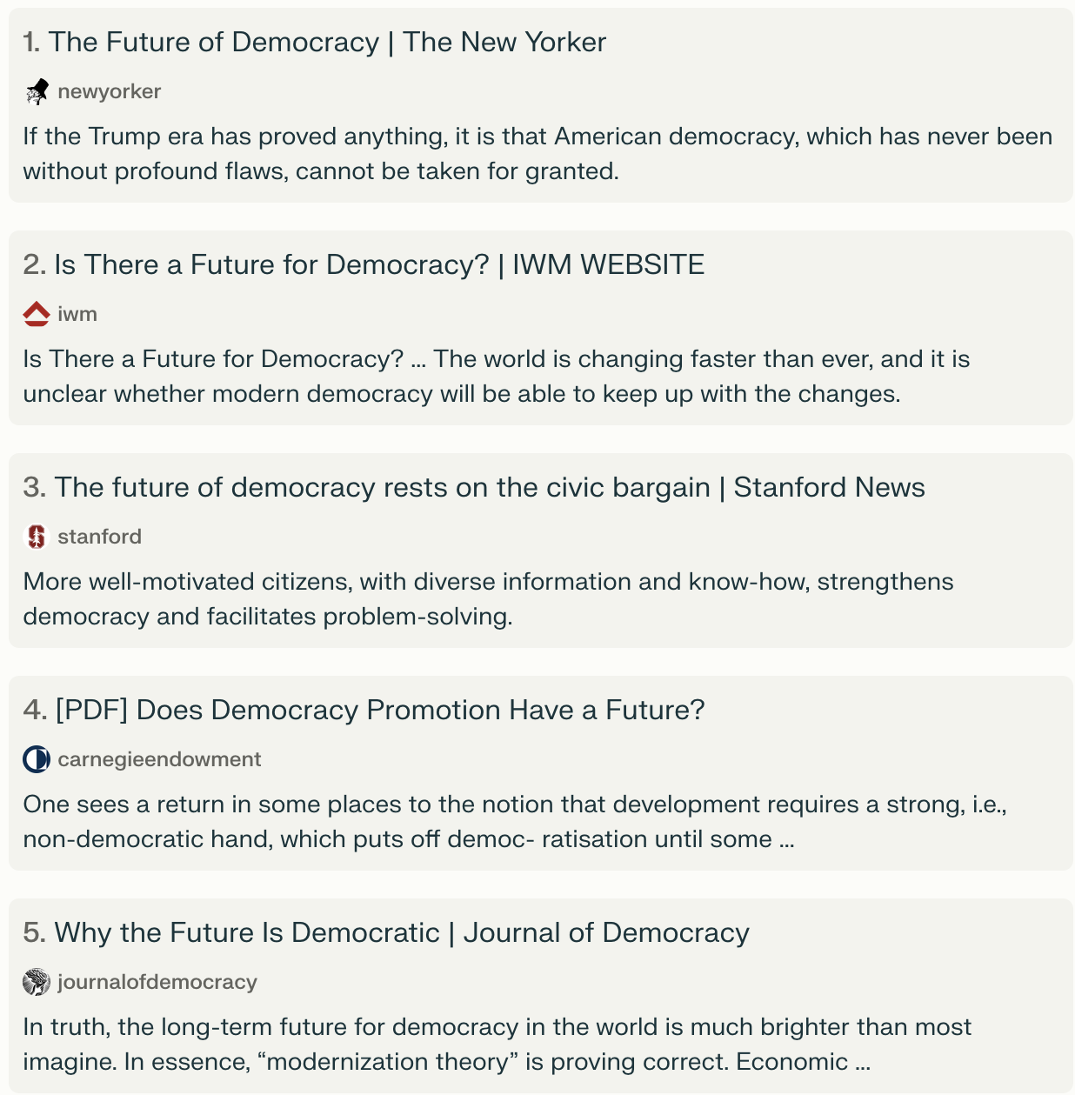
https://www.journalofdemocracy.org/articles/why-the-future-is-democratic/
https://carnegieendowment.org/files/DemocracyDevm-Carothers-sec.pdf
https://news.stanford.edu/2023/10/03/future-democracy-rests-civic-bargain
https://www.newyorker.com/news/the-future-of-democracy?verso=true
https://www.iwm.at/transit-online/is-there-a-future-for-democracy

