Hello Class,

Prop. Logic is similar to Syllogistic, except that you put an “If” before the premises and a “then” before the conclusion. So the Syllogism we have been using as an example,

All men are mortal

Socrates is a man

Socrates is mortal

Or All A is B, all C is A, therefore all C is B

Becomes

If all men are mortal and Socrates is a man, then Socrates is mortal (note the and is a Boolean And – we’ll come to that later when we get into computer logic)

The standard form for a Prop. Logic statement uses P and Q for Premises and Conclusion (Q.E.D.?) and goes like this, substituting a hypothetical for a syllogism:

P => Q (if P then Q, or P implies Q) = your hypothesis

“Proof” by testing goes

P (P occurs)

Therefore Q (the conclusion or result – i.e. Q happens)

This is called *modus ponens* a Latin term meaning “implication”

Real life example:

“Where there’s smoke there’s fire.” (hypothesis)

Smoke makes itself evident (event)

Conclusion = there must be a fire around here

Notice that in our example certain material things are our concern here – smoke, fire etc. This is called material conditionality – an important concern and much debated in later 20th century logic.

Here are a couple mind tests called the Wason Selection Task that will challenge your understanding of this logic:

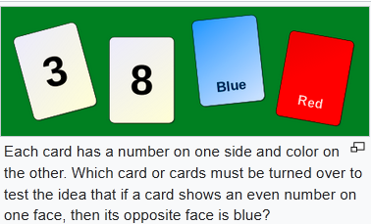

Cue: identify the hypothesis you are testing = IF a card shows an even number on one side it must have blue on the other side. Eliminate the cases that are immaterial to the hypothesis

Here is another test with a more social setting that most subjects find easier to solve

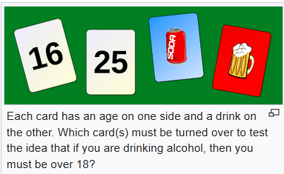

We’ll go over this in class – good luck!

(If you get too frustrated go to <https://en.wikipedia.org/wiki/Wason_selection_task>)