Truth Tables

Here is the Truth Table for P=>Q or *modus ponens* (the implication mode):

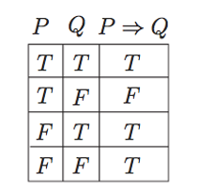

Our implication or hypothesis is that when two variables, P and Q, come together they have a relationship, P implies Q – this could be a causative relationship or simply something in a state of affairs.

The various rows in the truth table “test” our hypothesis – is it true or false so

Row 1 = we have P and Q happens – that is what our hypothesis predicted so P=>Q in the third column is True or T

Row 2 = we have P but no Q occurs – so that goes against our hypothesis and P=>Q gets a False or F – our theory has been shot down

Row 3 = we have a Q but no P to cause it – this one is tricky: P=Q is **not** unverified because there could be another cause for Q – other than P. Our hypothesis does not really speak to that situation so P=>Q gets a shaky or tentative T here

Row 4 = we have no P and no Q so we have not really tested P=>Q here so again we give it a pass or a T

Row 3 and 4 are called “vacuous Truths” by strict practitioners of Propositional Logic – like they can’t really be discussed in that logic, but they do have a place in other Logics, e.g. Modal Logic, where possibility or counterfactuals have more use – we’ll get to that later in the course

Hope this helps