**[](https://www.simplypsychology.org/)**

**Transactional Analysis Theory & Therapy: Eric Berne**

**By**

Heather Murray

Transactional Analysis (TA) is a [psychoanalytic theory](https://www.simplypsychology.org/psychoanalysis.html) and method of therapy developed by Eric Berne during the 1950s. Transactions refer to the communication exchanges between people.

During a conversation with someone, the person starting the communication will give the ‘transaction stimulus,’ and then the person receiving this stimulus (or message of communication) will give the ‘transaction response.’

Transactional analysis is the method used to analyze this process of transactions in communication with others. It requires us to be aware of how we feel, think, and behave during interactions with others.

TA recognized that the human personality is made up of three “ego states,”; each of which is an entire system of thought, feeling, and behavior from which we interact with each other. The Parent, Adult, and Child ego states and the interaction between them form the foundation of transactional analysis theory.

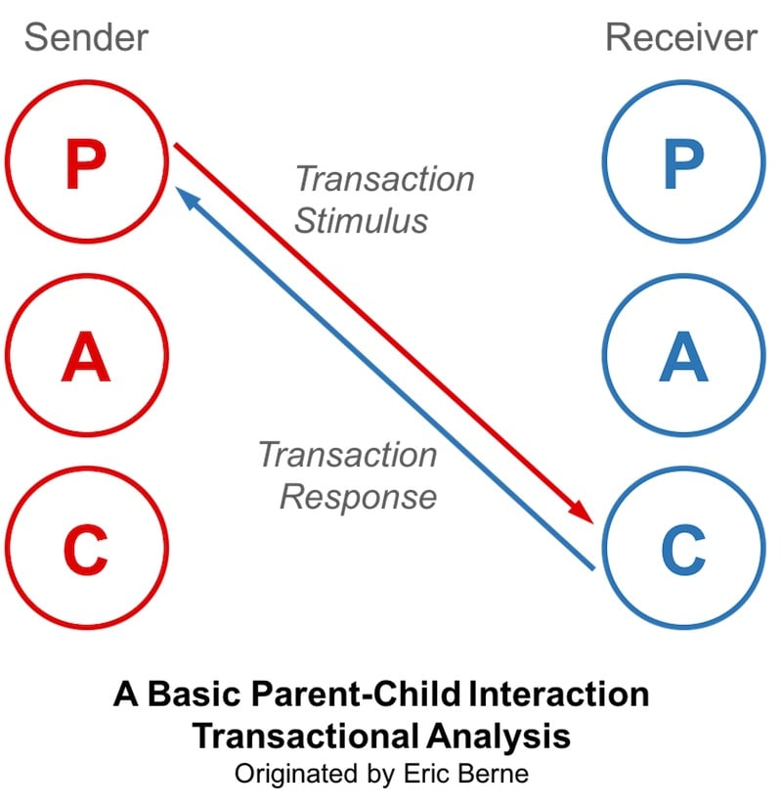

Transactional analysts are trained to recognize which ego states people are transacting from and to follow the transactional sequences to intervene and improve communication quality and effectiveness.

**How Was Transactional Analysis Developed?**

Eric Berne founded TA in the late 1950s. Eric Berne was born in Canada in 1910 and died in 1970; his field of expertise was rooted in psychoanalysis.

His ideas for TA developed from [Sigmund Freud’s psychoanalytic theory](https://www.simplypsychology.org/psychoanalysis.html) that childhood experiences greatly impact our lives as adults and are the basis for the development of our personalities and psychological or emotional issues that we suffer.

In the same way, Berne believed that our childhood experiences, particularly how we are parented, affect the developmental formation of our three ego states (Parent, Adult, and Child).

This can then unconsciously cause us to replay the same attitudes and behaviors that our parents had towards us to someone else during a conversation or to respond to communication and interactions with past childhood anxieties and emotions.

Eric Berne proposed that dysfunctional behavior is the result of self-limiting decisions made in childhood in the interest of survival. Such decisions culminate in what Berne called the “life script,” the pre-conscious life plan that governs the way life is lived out.

Changing the life script is the aim of transactional analysis psychotherapy. Replacing violent organizational or societal scripting with cooperative non-violent behavior is the aim of other applications of transactional analysis.

Since Berne created TA, other psychotherapists and psychologists, such as Thomas Harris and Claude Steiner, have added to it, developing the theory and its therapeutic applications further.

**The Ego States**

TA believes that we have three different states or ways of being during interactions, which are; the child ego state, the parent ego state, and the state of adult (Berne, 1957).

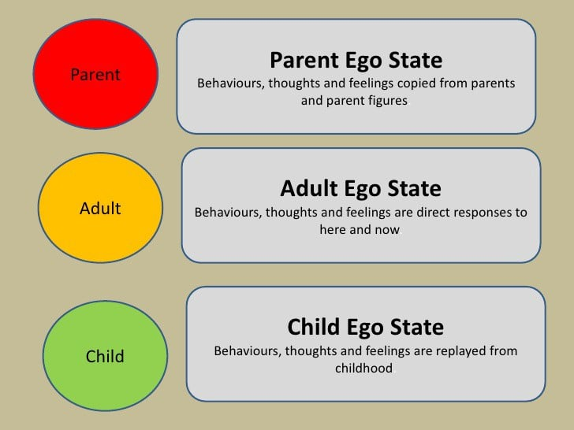

Which state we are in during an interaction depends on a few factors, such as how we have been conditioned to act or react from childhood, any past traumas that now cause us to act in a certain way during particular interactions or situations, and how the other person we are interacting with is treating us/ what ego state they are in when speaking to us.

Interacting with someone from the state of the child or parent mode is often a default or unconscious reaction that is used, and it takes conscious awareness to be able to bring ourselves back into adult mode and interact from that place instead.

**Child State**

There are two subdivisions of the child state; The adapted child and the free child ego states. This is when we interact and respond to someone based on our past conditioning of internal emotions felt in childhood, so when we revert back to our thinking and feeling from when we were children.

The child ego state is built on any reinforcements we were given in childhood, either positive or negative, to behave or not behave in a certain way, which still conditions and affects our interactions today.

The adapted child state conforms and acts according to others’ wishes to please them and be seen as good and liked. Still, it also has a rebellious side when faced with perceived conflict and causes responses of resistance, hostility, and emotional reactivity.

The free child ego state can be creative, spontaneous, playful, and pleasure-seeking.

**Parent State**

There are two subdivisions of the parent state; The critical/ controlling parent state and the nurturing parent state. These are behavior and thinking patterns we have been taught from our past interactions with our parents and other authority figures (teachers, grandparents, etc.).

Berne believed our experiences during our first five years of life contributed to the parent ego state. This state holds a lot of judgments on how someone or something is, i.e., it is that state where we find ourselves having a lot of ‘shoulds’ and ‘should nots’ about something.

People are in this state when they are reactive to a situation and act out of their conditioning, copying how their parents (or another authority figure) treated them and others instead of analyzing each situation afresh in the here and now.

It is when we use the voice of authority toward someone. The critical parent disapproves in a harsh and possibly aggressive way. In contrast, the nurturing parent tries to take over a situation in more of a rescuing way, trying to soothe others, which can be very inappropriate when talking to other adults rather than children.

**Adult State**

Unlike the other two, the adult state does not have any subdivisions. The adult state interacts with people and their environment in the here and now, not from past conditioning or how other people have told them to be.

This state is more open, more rational, and less quick to make harsh judgments on a situation or person.

When communication occurs in the adult state, we are more likely to be respectful, make compromises, listen fully to others, and have more healthy social interactions.

**How Do The Ego States Interact And Affect Communication?**

The three states of child, parent, and adult affect how we receive, perceive, and respond to information or communication from someone.

Berne observed that people need strokes, the units of interpersonal recognition, to survive and thrive. Understanding how people give and receive positive and negative strokes and changing unhealthy patterns of stroking are powerful aspects of work in transactional analysis.

Transactional analysis believes that adult-to-adult communication/ transactions lead to the most effective and healthy communication, thus, relationships with others.

The different types of transactions below explain how interactions from the different ego states interact with each other.

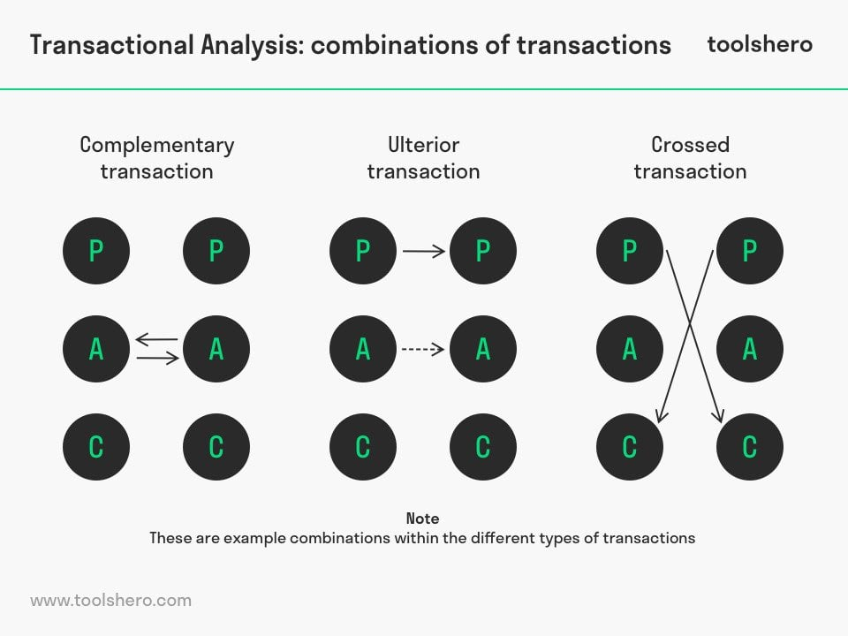

**Complementary Transactions**

It is important to note that although the phrase ‘complementary transactions’ sounds positive, it does not necessarily mean that this type of communication is always healthy communication.

A complementary transaction takes place when the lines between the sender’s and receiver’s ego state are parallel.

This means that whatever ego state the sender is in, their communication reaches or impacts the desired ego state of the receiver. Thus, the receiver responds in a way that complements the sender’s ego state instead of challenging it.

When this complementary transaction happens from an adult-to-adult state, it is thought to be the best type of communication, as it is respectful and reduces conflicts.

When a complementary transaction happens from the ego state of a child and is received and responded to from the ego state of a nurturing parent, it will also help to reduce conflicts and create a degree of harmony in the interaction; however, you can see why this would not necessarily be the best form of interaction in a workplace environment between two adults.

For example, in a marriage, if one partner is worried about an event, the other may take on a more nurturing parental state to help calm and support them, which is great; however, if this is the primary mode of communication between the two then over time it would cause strain and be quite draining.

**Crossed Transactions**

Crossed transactions are when the ego states of two people interacting do not match when the ego state of the sender does not reach the desired or intended ego state of the respondent; thus, they respond to the sender in a conflicting way (which can be seen by the crossed over arrows in the image to the right).

In a crossed transaction, it requires one or both of the people in the interaction to shift ego states for communication to be able to carry on.

An example of this would be if a customer came to you complaining of their recent purchase, using very belittling language, jumping to the conclusion that this mistake had been made purposely, and telling you that they were going to report you.

They are speaking to you from their critical parent state, intending you to then reply from your child’s ego state, such as being very apologetic, begging them not to report you, and responding with anything that strengthens their authority in the situation.

However, if you were to respond from your adult or parent state instead, this would cause a crossed transaction, and someone would have to shift their ego states to accommodate for this so the communication can continue.

TA believes that if you respond from your adult state, it is more likely that the sender can then also come back into their adult state to accommodate for the discrepancy in uncomplimentary ego states, resulting in transactions from adult to adult, which is healthier and more respectful.

**Ulterior Transactions**

Ulterior transactions are when the sender outwardly gives a message to the receiver that sounds like it’s coming from his adult state to the receiver’s adult state.

However, there is actually an underlying, subtle message given from the sender’s child or parent state, to be received by the responder’s child or parent state. Thus, two messages are sent at the same time. This can be done consciously or unconsciously by the sender.

This type of interaction is highlighted in the image showing the dashed line. An example would be if someone’s teacher or friend said, ‘You can choose to study subjects that lead to becoming a doctor; however, it is very hard and requires lots of intelligence.’

The use of language suggests adult-to-adult respectful communication with a subtle warning; however, they may have said it with the intent of triggering the receiver’s rebellious child ego state, so they might think, ‘I will show you that I am also very intelligent and can become a doctor’ and thus study harder.

The three different transactions in communication are not defined by verbal language and words alone. It also incorporates tone of voice, body language, and facial expressions.

**How Is Transactional Analysis Used In Therapy?**

The general goal or motive of TA therapy is to strengthen the adult state of the client. This is done through using skillful questioning and tools to understand what causes the client to shift into parent or child ego mode and thus come up with helpful strategies to use in these moments to stay in their adult state instead (Berne, 1958).

TA believes that our childhood experiences, particularly from birth to five years, strongly affect our behaviors and our responses in social interactions, so importance is placed on our upbringing and how we were parented.

This process is also referred to as script analysis, which analyses and explores our scripts developed in childhood. Scripts are unconsciously built beliefs and views we have of ourselves, others, and the world, which we developed to make sense of our internal and external environments from early experiences and interactions.

During script analysis, any positive or negative reinforcements we were given as a child to behave or not behave in a certain way will be explored, along with life messages we have given, I.e., ‘only lucky people become rich,’ or ‘you have to suffer to succeed.’

People will also explore whether or not they are modeling/ copying how they observed their parents and authority figures behaving.

Additionally, more subtle messages we received growing up will be analyzed (referred to as injunctions), such as always being told to be quiet when your parents were speaking to friends, which could imprint the belief ‘no one wants to hear me’ or ‘what I want to say doesn’t really matter,’ these would be explored in therapy along with how they currently affect our interactions now.

The parent, adult, and child diagram, or ‘structural diagram’ as Berne called it, is a useful tool that TA practitioners use as a helpful visual in aiding clients to understand the three states they have within them.

This affects their behavioral and social interactions and is a way of helping them to see how the three states interact with each other during particular situations and with particular people they communicate with.

TA can be used in short-term therapy, in a brief solution-focused way, or in a more in-depth long-term way to gain more insight into our unconscious world, and improving our relationships with others, and reduce conflict.

TA is versatile and can be used in individual psychotherapy, couple’s psychotherapy, and family counseling. It can also be helpful for other practitioners to apply to their work with clients such as nurses and teachers and even in industries such as business or sales training.

**Current Research On Transactional Analysis**

Current research on TA appears promising in its ability to improve relationships, decrease conflict, improve individual life satisfaction, and self-esteem. It also shows its effectiveness in aiding people at work during their interactions with clients.

Below are a few of these studies and their findings; more research on TA can be found online.

Nayeri, Lotfi, & Noorani (2014) provided 15 couples with group transactional analysis sessions. The couples attended eight sessions, each of 90 minutes.

The couples originally had very low scores of rated intimacy levels. When tested again after the 8 TA sessions, they showed significantly increased intimacy levels between every 15 couples. This increase remained stable when retested three months later.

This suggests that TA is a good educational and therapy tool to help improve intimacy and bonding in romantic relationships.

Similarly, Alkasir et al. (2017) provided 20 married women with 8 TA sessions and found that after the eight sessions, their reported marital discord, conflicts, and control-oriented behavior were significantly decreased, including economic control, intimidation, and emotional control.

The eight sessions led to increased marital intimacy and satisfaction, and the participants reported being able to apply the skills and knowledge learned in TA sessions to other areas of their life also.

A study by Saberinia & Niknejadi (2019) gave 15 mothers of children with oppositional deficiency disorder eight weekly 90-minute sessions of TA and found it to significantly improve their relationship with their children, minimizing conflicts and stopping any ‘games’ taking place between them as interactions would take place more frequently from adult-adult states.

Research also suggests that TA can help mothers to parent their children from a healthier authoritative parent style rather than authoritarian and permissive styles (regarding Baumrind’s three parenting styles).

This means that they have better control over their emotions and reactions and can communicate with their children from an adult position rather than taking part in conflicts and scolding them, which can lead to the improved well-being of the children (Eghbali, Mousavi, & Hakima, 2017).

Providing eight weekly, 90-minute TA sessions has been shown to improve prisoners’ self-esteem levels when testing 35 prisoners with a self-esteem test before beginning sessions and again after the eight sessions (Torkaman et al., 2020).

Lastly, a research study has shown that knowledge of TA theory, the ego states, and types of transaction can help psychiatric nurses to communicate and interact with their patients more effectively, which then leads to patients feeling more relaxed and responding better to treatment (Ertem and Eker, 2016).

**Critical Evaluation**

**Advantages**

* The first advantage of TA is that Berne created it with the intention of being straightforward, with easily understandable concepts. This makes it possible for the layperson to understand the theory and become familiar with its mechanisms and how social interactions in their lives take on the form that they do.
* TA helps people to be able to gain deeper insight into their own behaviors, reactions, thoughts, and emotions, which they might not have been aware of before, providing them with greater self-awareness.
* Another pro of TA is that it helps to improve communication skills and relationships with others while decreasing conflicts, and these benefits are supported by current research.
* A final pro is that TA can apply to many social environments/ interactions and many types of relationships. For example, work, colleagues and manager relationships or interactions, teacher and student interactions in schools, romantic relationships/ marriage, families, parent and child relationships, difficult clients at work in all industries, etc. Making it a very versatile theory.

**Disadvantages**

* A disadvantage of TA is that it requires someone to have a good degree of self-awareness and the capacity to look at and notice their own behavior, emotions, and thought patterns; some clients or people may not have this capacity.
* TA requires the client to be willing and motivated to take ownership of their problems and behaviors, so TA may not be suitable for everyone.
* TA was originally created by Berne to be simple and easy to understand, thus more accessible to the average person, however, with more recent psychotherapists and psychologists adding onto this theory, it has made it more complex, losing some of its originally intended simplistic nature.

**References**

Alkasir, E., Jafarian Dehkordi, F., Mohammadkhani, P., Soleimani Sefat, E., & Atadokht, A. (2017). Effectiveness of Transactional Analysis Group Training in Reducing Control-oriented Behaviors of Spouse in Marital Conflicts. *Iranian Rehabilitation Journal, 15* (1),57-64

Berne, E. (1957). Ego states in psychotherapy. *American journal of psychotherapy, 11* (2), 293-309.

Berne, E. (1958). Transactional analysis: A new and effective method of group therapy. *American Journal of Psychotherapy, 12* (4), 735-743.

Eghbali, M., Mousavi, S. V., & Hakima, F. (2017). The effectiveness of transactional analysis on mothers” parenting styles. *Journal of Family Psychology, 3* (2), 17-26

Ertem, M, Y., & Eker, F. (2016). Therapeutic Approach in Psychiatric Nursing: Transactional Analysis. *Annals of Clinical and Laboratory Research, 4* (1:56)

Nayeri, A., Lotfi, M., & Noorani, M. (2014). The effectiveness of group training of transactional analysis on intimacy in couples. *Procedia – Social and Behavioral Sciences. 152*, 1167-1170

Saberinia, S., & Niknejadi, F. (2019). The Effectiveness of Transactional Analysis on Parent-Child Relationship in Mothers of Children with Oppositional Defiant Disorder. *Avicenna Journal of Neuropsychophysiology. 6* (2), 83-90

Torkaman, M., Farokhzadian, J., Miri, S., Pouraboli, B. (2020). The effect of transactional analysis on the self-esteem of imprisoned women: a clinical trial. *BMC Psychology, 8* (3)

From [Transactional Analysis Theory & Therapy: Eric Berne (simplypsychology.org)](https://www.simplypsychology.org/transactional-analysis-eric-berne.html))