Historical Rates of Travel in the United States

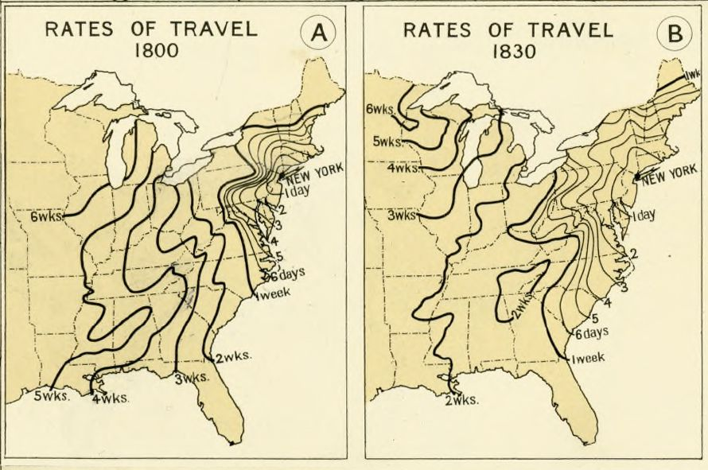[1]

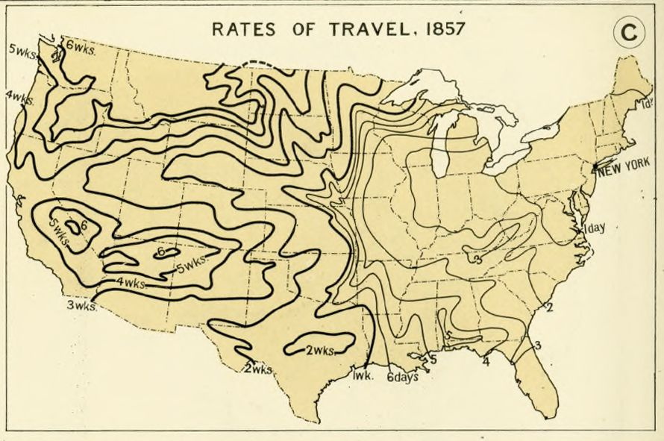

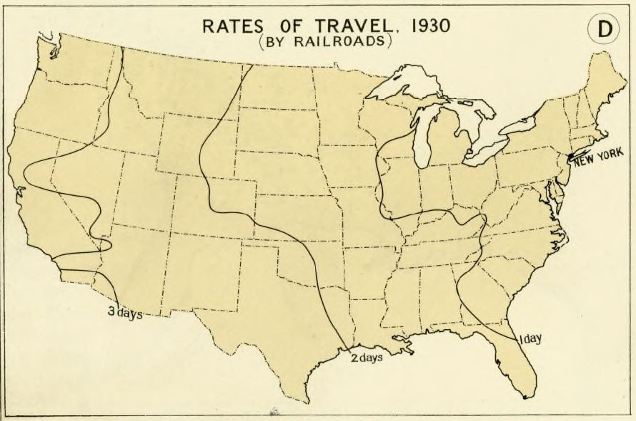

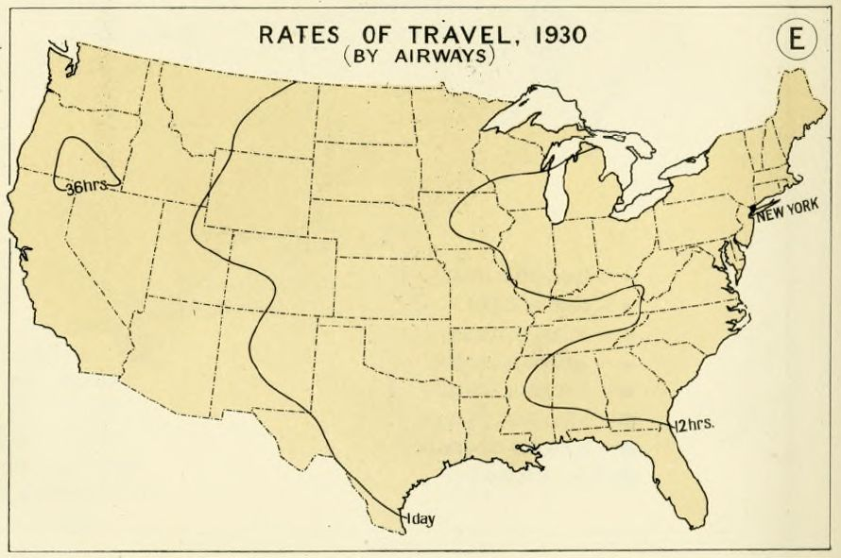

Original at <https://www.davidrumsey.com/luna/servlet/detail/RUMSEY~8~1~248429~5516150>

“Rates of Travel, 1800-1930.” Atlas of the Historical Geography of the United States, by Charles O. Paullin, ed. John K. Wright, published by the Carnegie Institution and the American Geographical Society, 1932. [David Rumsey Map Collection.](http://www.davidrumsey.com/luna/servlet/detail/RUMSEY~8~1~248429~5516150)

* 25 mph
* Infrastructure of tracks was relatively poor until late 1800’s saw additional investments
* Still limited by curves, grade, and stops

1. All maps courtesy of Hathi Trust -- <https://catalog.hathitrust.org/Record/000340001>