**MEMOIR WRITING: YOU HAVE A STORY TO TELL**

**Class Notes and Reminders – 02/03/25**

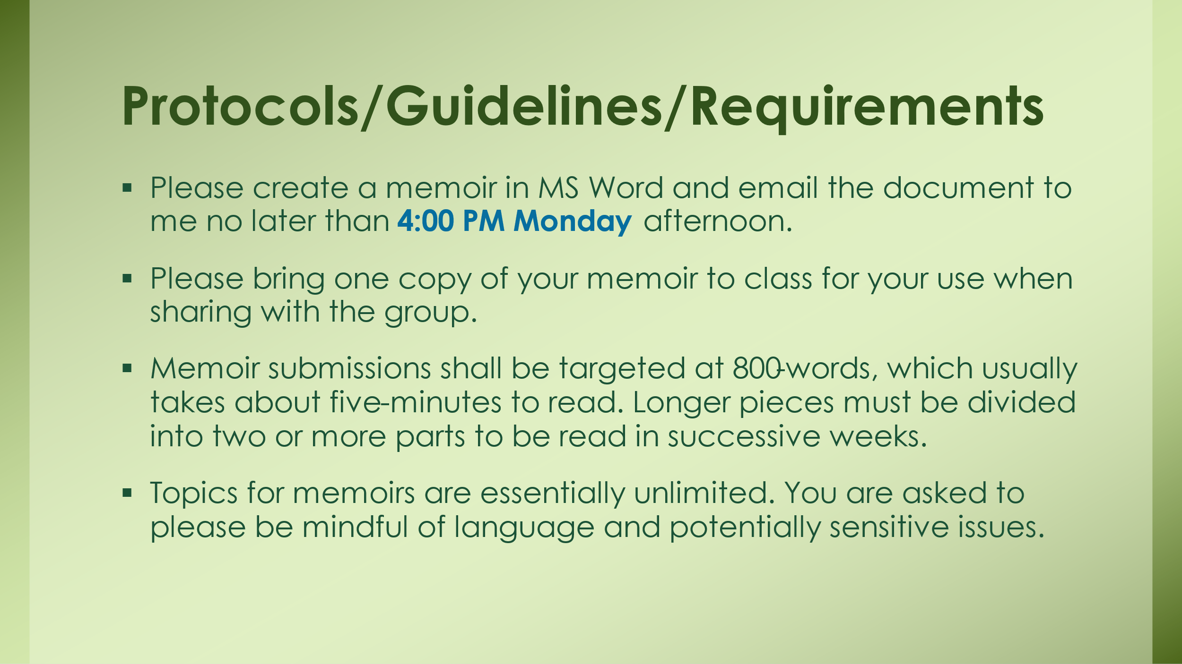

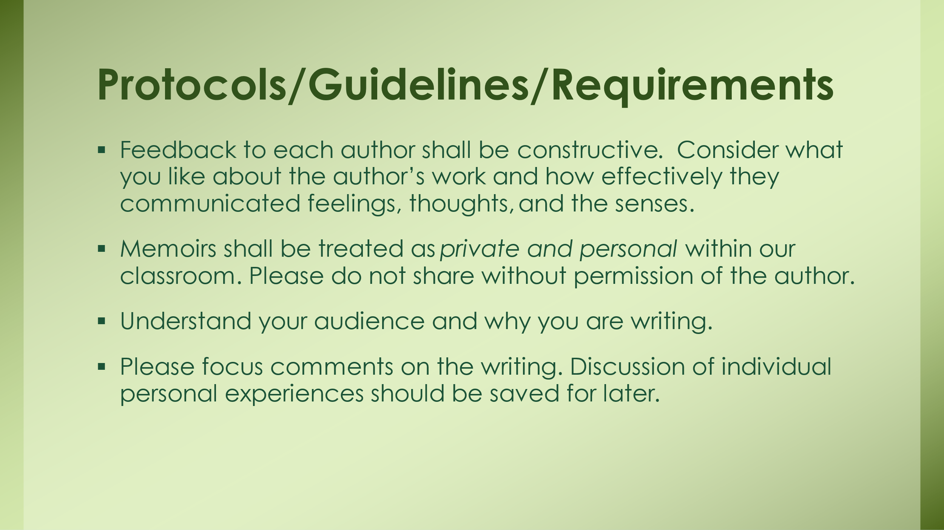

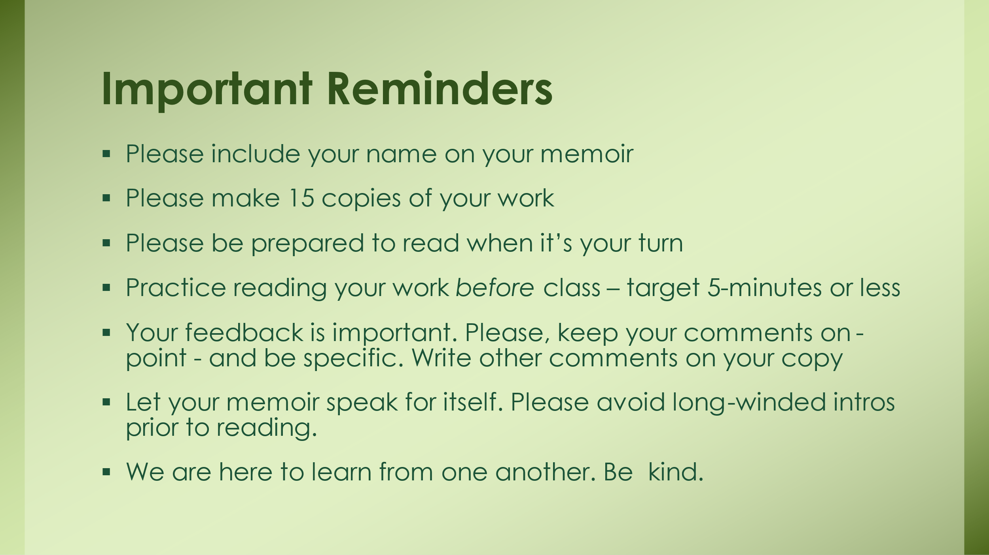

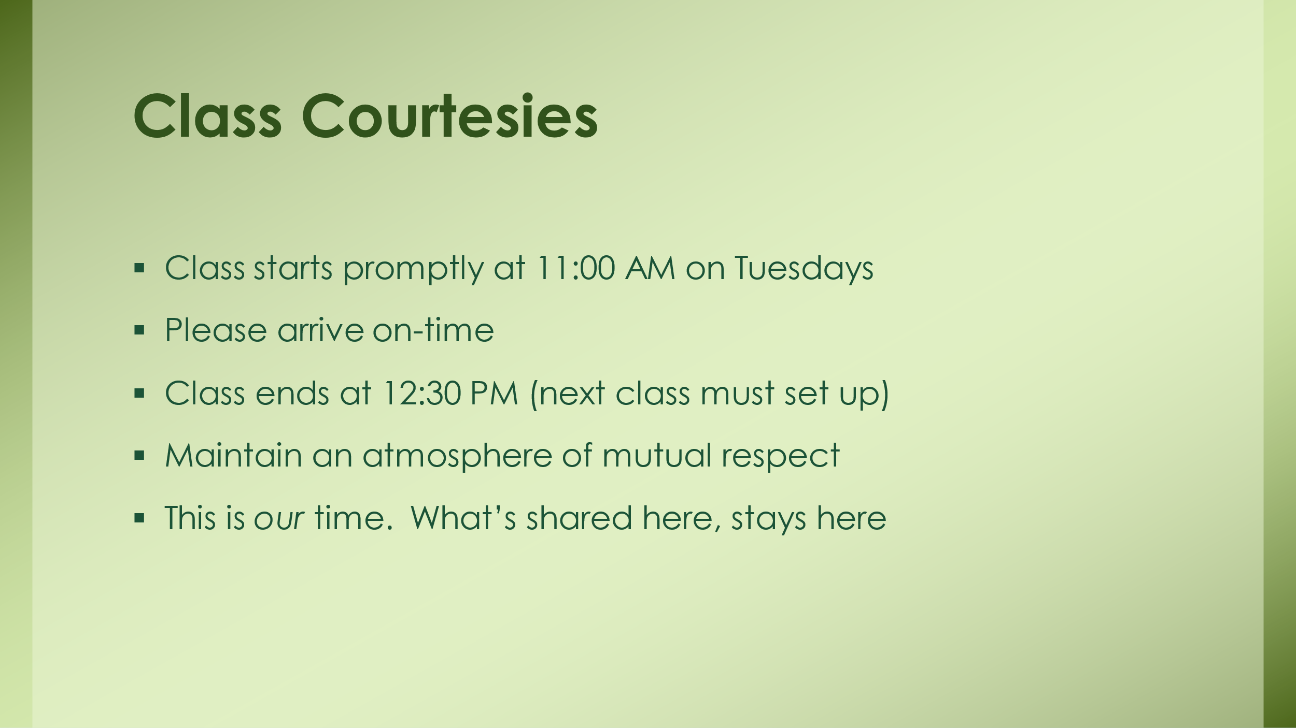

*Thank you for enrolling and sharing your time!*