Donald J. Trump: My Tariffs Have Brought America Back
The ‘experts’ predicted market crashes, massive inflation and recession. They were all wrong.

By Donald J. Trump Jan. 30, 2026 4:03 pm ET
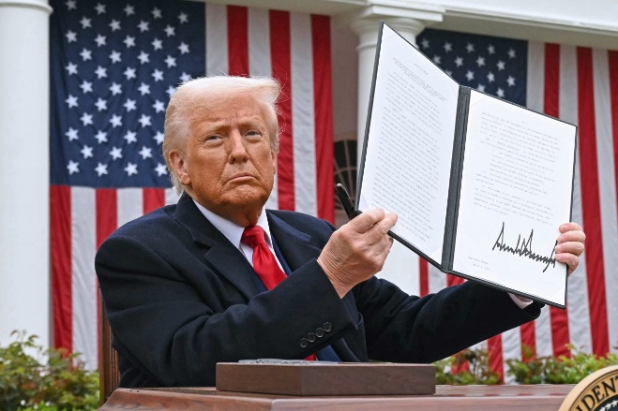
President Trump holds up an executive order on tariffs, April 2, 2025. saul loeb/Agence France-Presse/Getty Images

When I imposed historic tariffs on nearly all foreign countries last April, the critics said my policies would cause a global economic meltdown. Instead, they have created an American economic miracle, and we are quickly building the greatest economy in the history of the world, with other countries doing just fine!
Countless so-called experts, including those featured frequently in The Wall Street Journal, predicted confidently that the Trump tariffs would crash stock markets, crush economic growth, cause massive inflation, destroy American exports, and trigger a “worldwide recession.” Nine months later, the results are in, every one of those predictions has proven completely and totally wrong. Since I was elected in 2024, we have had 52 stock market highs, with virtually no inflation. There has never been anything like it!
I inherited an economy ravaged by the radical policies of Sleepy Joe Biden and his allies in Congress. Their trillions of dollars in wasteful spending and their extremist green energy agenda created the worst inflation in more than 40 years, costing the typical American family $33,000 in real wealth. The Biden years were defined by the misery known as “stagflation”—high inflation and low growth.
Only 12 months into my second term in office, we now have the exact opposite—extremely low inflation, and extraordinarily high economic growth!
In the third quarter of 2025, gross domestic product growth was booming at 4.4%, and despite the Democrat-induced shutdown last fall, which cost us at least 1 point, the fourth quarter is projected by the Atlanta Fed to be well over 5%, a number like our country has not seen in many years.
Meanwhile, annual core inflation for the past three months has dropped to just 1.4%—far lower than almost anyone, other than me, had predicted. Economic growth does not cause inflation—in fact, often it does the exact opposite. Real incomes for the typical worker rose $1,000, $2,000 or even more last year, increasing much faster than consumer prices. Wages far outpaced inflation. Since “Liberation Day,” the stock market has skyrocketed, with the strong possibility that we will soon break 50,000 on the Dow Jones Industrial Average, something which everyone thought was impossible, at least in one year!
Joe Biden handed me a catastrophically high budget deficit, and the highest trade deficit in world history. But with the help of tariffs, we have cut that federal budget deficit by a staggering 27% in a single year, and even more incredibly, we have slashed our monthly trade deficit by an astonishing 77%—all with virtually no inflation, which everyone said could not be done. American exports are up by $150 billion. Domestic steel production is up by more than 300,000 tons a month. Factory construction is up by 42% since 2022. China’s share of U.S. imports has reached the lowest level since China entered the World Trade Organization in 2001—and hundreds of billions of dollars more are pouring into the United States. I sincerely hope the Supreme Court is watching these numbers, because our country has never seen anything like them!
Just over one year ago, we were a “DEAD” country. Now, we are the “HOTTEST” country anywhere in the world!
The entire Trump economic agenda deserves credit for this explosion of growth and good news, including our record tax cuts, unprecedented regulation cuts, pro-American energy policies and much more!
But without question, the credit for this economic success must go to what the Journal itself described as “the largest economic policy shock” in more than 50 years—my tariffs! We have proven, decisively, that, properly applied, tariffs do not hurt growth—they promote growth and greatness, just as I said all along.
The Journal has charged repeatedly that tariffs are nothing but a “tax” on American consumers, which has proved to be totally false. Experience since Liberation Day has proved that this analysis is not only far too simplistic—it is absolutely wrong! The data shows that the burden, or “incidence,” of the tariffs has fallen overwhelmingly on foreign producers and middlemen, including large corporations that are not from the U.S. According to a recent study by the Harvard Business School, these groups are paying at least 80% of tariff costs.
In many cases, nations that are heavily dependent on exports have had no choice but to “eat” the tariffs to avoid even worse losses from their excess capacity. So, while the average U.S. tariff rate on foreign products has increased by more than five times, inflation has fallen dramatically!
At the same time, I have successfully wielded the tariff tool to secure colossal Investments in America, like no other country has ever seen before. By his own accounting, in four years, Joe Biden got less than $1 trillion of new Investment in the United States. In less than one year, we have secured commitments for more than $18 trillion, a number that is unfathomable to many.
The world’s largest auto companies are now investing over $70 billion in America. Taiwan Semiconductor Manufacturing Co., Micron, Nvidia, Apple and others are investing hundreds of billions to build cutting-edge semiconductors and chips in the U.S. The world’s largest pharmaceutical companies are investing some $500 billion to reshore production of critical medications. My most favored nation agreements to lower drug prices by up to 90% could not have happened without the threat of tariffs.
The global “retaliation” against American products that so many pundits predicted last April never materialized—just the opposite. Since Liberation Day, I have made historic trade deals with China, the U.K., the European Union, Japan, South Korea, Vietnam, Indonesia, the Philippines, Malaysia and others covering a majority of all U.S. Trade. These deals have reduced barriers to U.S. exports and caused stock markets to boom not only in America, but in virtually every country that has come to the table to make a deal. More important, the agreements are forging more sustainable relationships with many of our allies and partners, expanding our military alliances into the realm of economic security for the first time.
As a key part of the agreement we negotiated with South Korea as a result of my tariffs, Korean companies are investing $150 billion to revive the domestic shipbuilding industry in the U.S. Japan will help us construct one of the largest natural-gas pipelines in the world, in Alaska, to export American energy to our allies in Asia. Europe has likewise agreed to buy $750 billion of U.S. energy to reduce their dependence on foreign adversaries. Countries all over the world have agreed to purchase hundreds of state-of-the-art aircraft and airplane engines from U.S. factories, creating thousands of jobs and strengthening our defense industrial base.
Other countries are opening their markets to tens of billions of dollars in American agricultural exports, and still more have become leading customers and investors in the American artificial-intelligence ecosystem, helping us solidify our dominant position as the world’s AI superpower. We are substantially leading every other country. Since Liberation Day, we have also signed agreements worth billions of dollars in foreign military sales.
Given all of this, it is simply undeniable that my tariffs have strengthened our national security immeasurably. Nowhere has this been clearer than when it comes to our historic achievements in making PEACE. In nine months, I settled eight raging conflicts, WARS, and tariffs deserve much of the credit, including helping settle the extremely dangerous and deadly conflict between India and Pakistan.
It was the tariff that made America strong and powerful in generations past, and it is tariffs that are making our country stronger, safer and richer than ever before. Given the results of the past year, and the spectacular economic numbers coming out every single day, perhaps it is time for the tariff skeptics at the Journal to consider putting on one of my favorite red hats—the one that reads, “TRUMP WAS RIGHT ABOUT EVERYTHING!”
Mr. Trump is president of the United States.

