The Effects of Tariffs, One Year Into Trump’s Trade Experiment
Five charts show the impact on the economy after a year of sweeping trade changes by the Trump administration
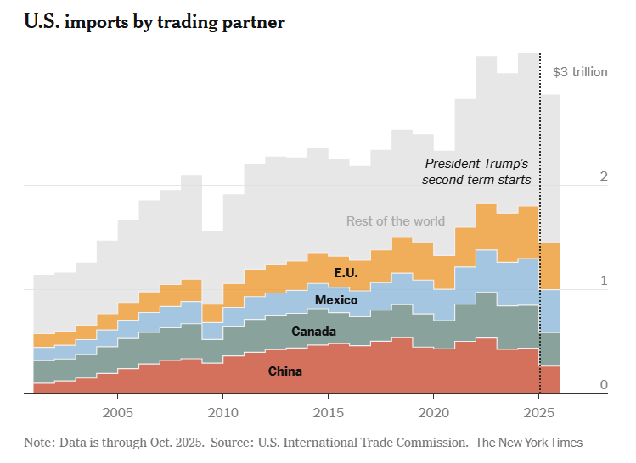

By Ana Swanson
Ana Swanson covers international trade and reports from Washington.
Feb. 2, 2026, 5:01 a.m. ET (NY Times)
Over the past year, President Trump carried out what was essentially a grand experiment with the U.S. economy, by raising tariffs to levels not seen in a century. It was an exercise that pitted Mr. Trump, a longtime proponent of tariffs, against business owners who paid the levies and mainstream economists who criticized the plan.
America imports trillions of dollars of foreign goods each year, and tariffs are a tax on those purchases. Over the past year, Mr. Trump raised average U.S. tariffs to about 17 percent, the highest level since 1932, in the wake of the 1930 Smoot-Hawley Tariff Act. Mr. Trump’s stated aim was to reinvigorate American industry and bring jobs back to the United States.
These new surcharges have had a significant impact. They have caused businesses to speed up, delay and cancel purchases, or find new countries to source products from. They have raised a significant amount of revenue for the government, much of it from American businesses. And they have caused the U.S. trade deficit to shrink and prices of American goods to rise. At the same time, they have not yet been the panacea for the factory sector that Mr. Trump had promised.
Here are some of the effects.
Skyrocketing revenue
One of the most tangible effects of Mr. Trump’s trade policy has been a drastic increase in the revenue the government takes in from tariffs. The United States collected an estimated $287 billion in customs duties, taxes and fees last year, nearly triple the amount in 2024.
Monthly tariff revenue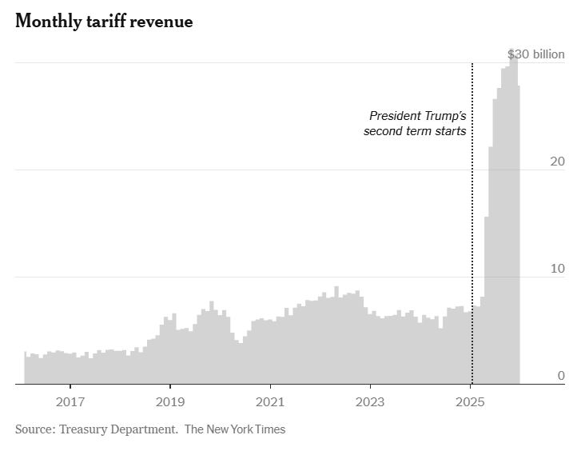
This amount is still small compared with the more than $2 trillion earned annually from income taxes, but it gives the government a significant new source of money for its spending, whether that’s funding the military or Social Security, or paying interest on the U.S. debt.
There’s an important caveat, however. This money was paid to the government by so-called “importers of record,” most of which are American companies.
While the Trump administration has said that foreign firms will end up paying the tariffs, most economists believe that American businesses and consumers bear most of the burden.
A shrinking trade deficit
Mr. Trump has also sought to decrease the trade deficit, which is the gap between what the United States buys versus what it sells overseas. In recent months, he has succeeded. The trade deficit has fallen significantly, hitting its lowest level since 2009 in October, though it rebounded in November.
Quarterly trade deficit
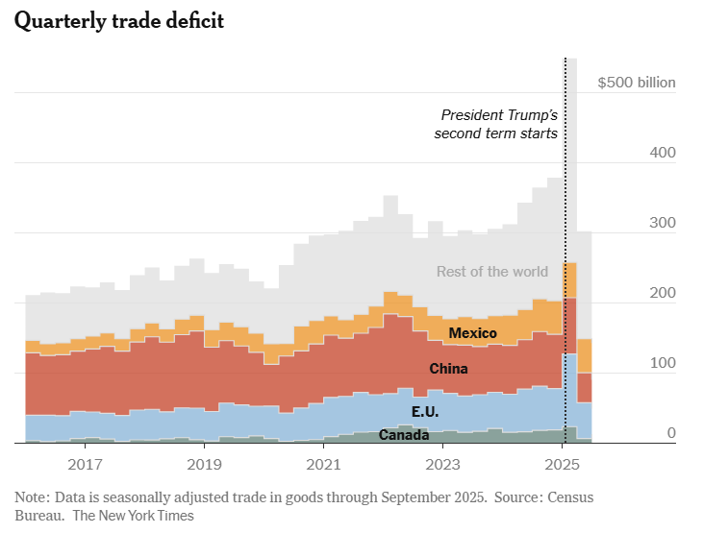
The president and his supporters see the trade deficit as a sign of economic weakness, though not all economists agree. While the trade deficit has fallen a lot in recent months, it had surged earlier in the year as Mr. Trump came into office and businesses rushed to bring goods into the country ahead of the tariffs. From January to November, the trade deficit is still up 4.1 percent from the previous year. The question now for economists is where the trade deficit will go from here.
Mixed results for the factory sector
One goal Mr. Trump hasn’t accomplished is helping factory workers. Despite the tariffs, the manufacturing sector continued to shed jobs last year.
Many of Mr. Trump’s supporters argue that it will take time for factories to be built and this trend to be reversed. They have pointed to recent gains in industrial production and capital expenditure to suggest that the country is on the verge of a manufacturing boom because of tariffs.
Manufacturing indexes
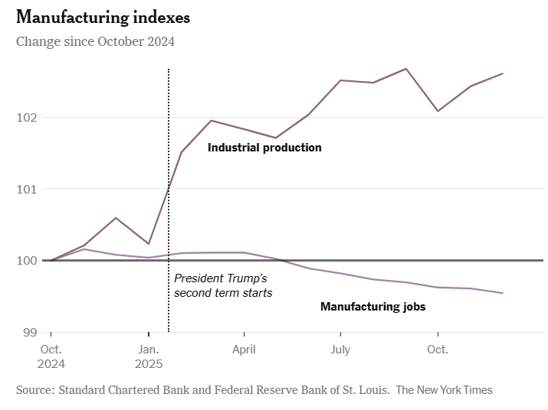
But there are reasons to be skeptical. Much of the upturn in industrial production is attributable to growth in the aerospace and electronics sectors, which are among the least burdened by tariffs. For makers of cars and car parts, which have been subject to hefty tariffs, production fell last year. Some manufactures say tariffs are harming them by increasing the cost of the metal and machinery they need to run their factories.
And while spending on the construction of new factories is much higher than before the pandemic, it’s down from the end of the Biden administration, when grants to semiconductor and battery factories were encouraging construction.
There are forces other than tariffs that may be helping industries, like a boom in A.I. data center construction and new tax policies that allow companies to write off the cost of new equipment.
Tariffs have pushed up prices
Unsurprisingly, tariffs pushed up the prices of imported goods last year. Economic tracking shows that prices began climbing particularly after Mr. Trump announced sweeping global tariffs in April, reversing a trend of falling prices in previous months.
The price effects from tariffs have, however, been somewhat smaller than many originally anticipated, partly because companies have been hesitant to raise prices for fear of losing customers.
Retail price indexes by country of origin
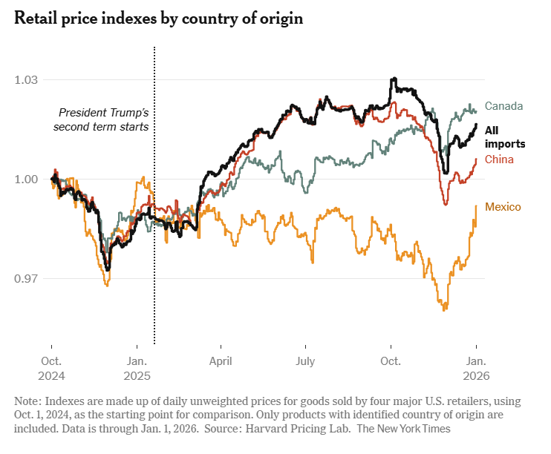
The picture for U.S. inflation has also improved, partly because of a gradual cool-down for inflation in services. But economists say it would look better without tariffs: By one estimate, the Consumer Price Index in August, which was 2.9 percent, would have been 2.2 percent without tariffs.
Beyond the economic data, many Americans remain concerned about high prices, and they have turned more skeptical of Mr. Trump’s handling of the economy, which has traditionally been a strength for him.
A poll from The New York Times and Siena University in January found that 54 percent of voters oppose Mr. Trump’s tariffs, and 51 percent said the president’s policies had made life less affordable for them.
Ana Swanson covers trade and international economics for The Times and is based in Washington. She has been a journalist for more than a decade.

