The Wason Selection Task
This is an exercise to help understand logical inference under material conditionality. The “task” is to establish valid inferences
- In this exercise you are to identify which cards you must turn over to establish the inference “If a card shows an even number on one face, then it’s opposite face is blue”

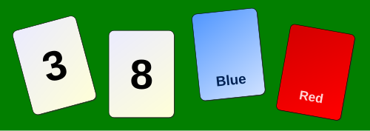

Note: Over 90% of subjects fail to get this one; it is a straight If P then Q modus ponens – be warned to make sure you properly identify what P and Q are

- This one is the same idea, but for various reasons is much easier for subjects to get. The task is which cards must be turned over to test the idea that “if you are drinking alcohol you must be over 18”
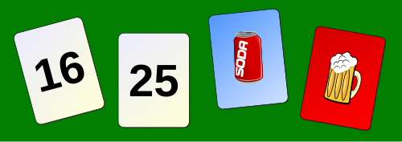
Again think through what the P and the Q are. Good luck!

