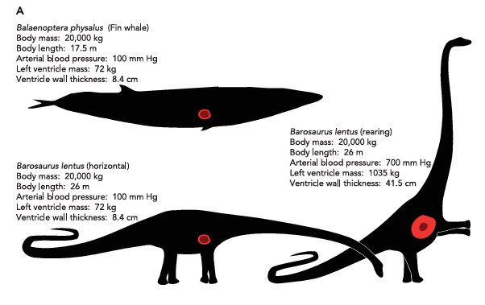
Recent article on dinosaur cardiovascular physiology of dinosaurs.
https://journals.physiology.org/doi/epdf/10.1152/physiol.00016.2016
Dino hearts had 4 chambers.
Article includes calculations about blood pressure
There are at least two major scenarios of the world if dinosaurs survived to the present.
One is where they haven’t changed that much in 66 MY as compared to the approximately 133 MY when they ruled the earth. Physically and mentally not much eveolution. So you see the same creatures from the Mesozoic.
Another scenario is where they evolved physically and mentally into the” dinosaurids”.
www.msn.com/en-us/money/topstocks/dinosaurs-could-have-become-humanlike-the-dinosauroid-theory-explained/vi-AA24H7KW
More of an artists’ concept than an evolutionary biologist’s estimation.
I would think that the loss of arm function – wings, disappearance by non use or whatever, would have limited the further evolution of dinosaur intelligence. Beaks or mouths are somewhat limited in overall function. There is the idea of hand-eye coordination that would limit further evolution.
Article on effect of dinosaurs on modern ecosystems.

dino-world.com/what-would-modern-ecosystems-look-like-if-dinosaurs-still-existed-5-11212/

This site has numerous interesting articles about dinosaurs and is updated on a relatively regular basis. There is a search magnifier to locate different subjects.

One can find numerous dino related articles on internet. Just type in a particular search term.

I think the internet software will pick up your interest and post various stories on a daily basis also.

Images included in the articles are often not related to the article and are commonly not labeled like the attached image.


Additonal sources in Tuesday’s presentation
The Digital Morphology library is a dynamic archive of information on digital morphology and high-resolution X-ray computed tomography of biological specimens. Browse through the site and see spectacular imagery and animations and details on the morphology of many representatives of the Earth's biota. Believe most of the images are endocasts of skulls. University of Texas at Austin
https://www.digimorph.org/index.phtml

Very good croc video

https://www.msn.com/en-us/video/animals/watch-a-2-ton-saltwater-crocodile-explode-out-of-water-it-happens-in-seconds/vi-AA22Avr1

