Night of Violence Grips Northern Ireland After Stabbing Attack
Cars and a bus were set on fire and families were driven from their homes as the stabbing attack caused tensions to spill onto the streets.
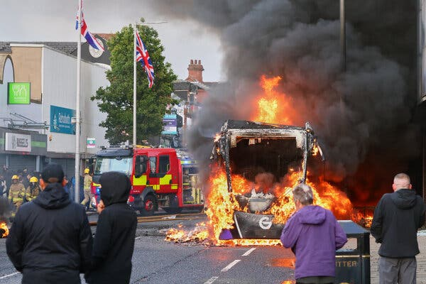
Belfast, Northern Ireland, on Tuesday.

June 10, 2026
Political leaders and police in Northern Ireland were urging restraint on Wednesday morning after a night of violence roiled the country in the wake of a brutal stabbing attack in Belfast.
Firefighters and emergency responders escorted immigrant families from their homes that had been set alight in Belfast on Tuesday night, as burning cars blazed on the street. A city bus was set on fire by young men on Newtownards Road in east Belfast, and garbage cans engulfed in flames were used to create roadblocks elsewhere in the city.
The unrest came after authorities charged Hadi Alodid, 30-year-old Sudanese man, with attempted murder in the stabbing attack Monday night, prompting calls from anti-immigrant activists for protest amid heightened tensions in the United Kingdom over immigration.
The Police Service of Northern Ireland said in a statement issued late Tuesday that “sporadic pockets of disorder” had broken out in a number of locations across Northern Ireland.
Mr. Alodid, a refugee who is legally residing in the United Kingdom, appeared in a Belfast court on Wednesday morning. As misinformation and speculation about the attacker continued to swirl online, the police reiterated that the suspect remained in custody in a police station before his court appearance.
Graphic video of the attack showing the suspect swiping at the victim, whose face and neck are covered in blood, quickly spread online on Tuesday.
The prosecutors who charged Mr. Alodid identified the victim as Steven Ogilvy. He is in the hospital with serious injuries to his face, neck and back, and prosecutors said he had lost an eye as a result of the attack,
Michelle O’Neill, the First Minister of Northern Ireland, appealed for calm, saying there could be “no excuse and no justification for these attacks,” in a statement issued early on Wednesday.
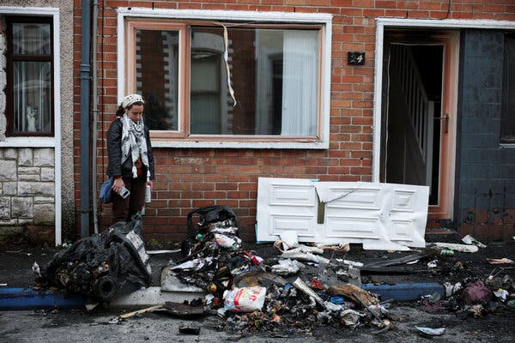
Charred debris in east Belfast on Wednesday morning, after a night of violent protests.
“Groups of masked men burning families out of their homes is nothing less than disgusting cowardice. This has nothing to do with community. This is outright thuggery,” she wrote. She called the earlier stabbing attack in north Belfast “heinous and wrong,” but added that “there are dangerous attempts to exploit that to target and attack innocent people who are simply trying to live, work and raise their families here.”
Among those stoking outrage over the stabbing was Tommy Robinson, a far-right English agitator with a number of criminal convictions. Mr. Robinson, whose real name is Stephen Yaxley-Lennon, had urged people to take to the streets after what he called an “invader attack on our people” in posts on social media. The billionaire Elon Musk had shared lists of locations around Northern Ireland for people to gather and shared posts by far-right figures in Britain.
Prime Minister Keir Starmer, in a statement posted on the social media platform X called the scenes of violence in Belfast “shocking and completely unacceptable.”
“There is no justification for the violence and disorder that we saw threatening our communities, nor for those who encouraged it, online or elsewhere,” he said. “It is clear that people were targeted last night because of their background and I will not tolerate it.”
Northern Ireland is the least ethnically diverse part of the United Kingdom, with just approximately 3.4 percent of residents from minority ethnic backgrounds.
But in the years since the 1998 Good Friday Agreement forged peace in the region after decades of sectarian violence, immigration to Northern Ireland has grown, and it is steadily becoming more diverse, particularly in urban areas like Belfast.

