Japa Times/ July 16 2026

39% support imperial succession by sons of adoptees: poll

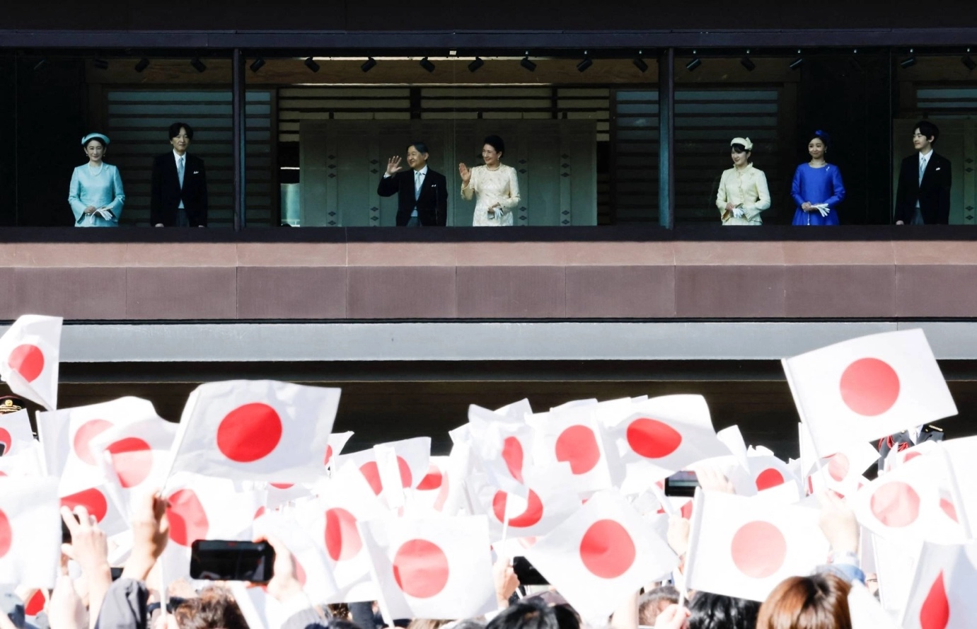

Emperor Naruhito and other members of the imperial family wave to well-wishers at the Imperial Palace in Tokyo in February. | REUTERS
JIJI
SHARE/SAVE
Jul 16, 2026
Listen to this article
2 min
A Jiji Press opinion survey has found that 39.5% of respondents support the government’s proposal to allow sons of paternal-line male descendants from former imperial family branches to ascend the throne.
Meanwhile, 26.9% voiced opposition to the proposal, while 33.6% said neither or that they are undecided.
A government-sponsored bill aimed at helping increase the number of imperial family members, which is now being debated by parliament, stipulates that paternal-line male descendants from former imperial family branches can be adopted back into the family and that male children of such adoptees will have the right of succession to the throne.
The opinion poll also showed that 34.0% support granting imperial family status to the husbands and children of female imperial family members who will remain in the family after marriage. The share of respondents opposing the idea came to 27.5% while 38.5% said neither or that they are undecided.
The bill to amend the Imperial House Law does not grant imperial family status to such husbands and children.
Among supporters of the ruling Liberal Democratic Party, the proportions of respondents who are in favor of the ideas to allow male offspring of adoptees to ascend the throne and to give imperial family status to the husbands and children of female members both topped the shares of those who are not.
The results were the opposite among supporters of the Japan Innovation Party (Nippon Ishin no Kai), the coalition partner of the LDP.
Among supporters of the Constitutional Democratic Party of Japan and the Japanese Communist Party, both of which are critical of the legislation, many said they oppose allowing sons of adopted descendants to inherit the throne while showing support for giving imperial status to the husbands and children of female imperial family members.
The interview-based survey, conducted from Friday through Monday, covered 2,000 people age 18 or over across the country. Valid responses came from 57.1%.

Japan's Lower House passes bill to secure number of Imperial family members
Friday, July 10, 1:35

- 

Japan's Lower House has approved a bill to revise the Imperial House Law with the aim of securing the number of Imperial family members.
The legislation is also likely to clear the Upper House for enactment during the current Diet session.
Under one revision, females would stay in the Imperial family after marriage. They currently leave the household when they marry outside the Imperial family.
The bill also enables the adoption of male descendants in the male line of former Imperial branches. The adoptees would not be able to succeed the throne, but their male offspring would be eligible.
The governing Liberal Democratic Party and its coalition partner, Japan Innovation Party, were among those that voted for the bill on Friday.
From the opposition, the Centrist Reform Alliance, the Democratic Party for the People and Sanseito came on board.
The Japanese Communist Party and Reiwa Shinsengumi were among those that voted against the bill.
Team Mirai let its members vote in accordance with their own judgments.
A supplementary resolution was also adopted at a Lower House committee. It calls for continued studies on ways to ensure a stable Imperial succession, based on developments in the number of household members.
The Imperial family currently consists of Emperor Naruhito and 15 others. Under the Imperial House Law, the Imperial Throne is succeeded by males in the male line.
At present, only three members are eligible, and of them, only Prince Hisahito belongs to the family's younger generation. This has raised concerns over the future of the Imperial succession.

Japanese News Report
https://youtu.be/9VnagyCwi8U?si=te3h8e40V30dQdSt

July 17 AP

BY MARI YAMAGUCHI
Updated 5:21 AM GMT-7, July 17, 2026
TOKYO (AP) — Japan’s parliament enacted a historic revision to the 19th-century Imperial House Law on Friday by insisting only paternal-lineage men can become emperor, sparking concern that the measure could doom the already shrinking imperial family.
The revisions include adoption of distant male relatives to father future heirs and allowing princesses to keep their royal status after marrying commoners.
Royal watchers and experts fear the new measures could doom the 1,500-year-old hereditary institution by insisting that only males can be emperor.
Emperor Naruhito ’s 24-year-old daughter is hugely popular, and many Japanese want her to be his successor, but Princess Aiko is ineligible because she is a woman. Japan’s male-only succession rule means the line must move to the emperor’s younger brother, then to his 19-year-old nephew Prince Hisahito. Next in line after him is the emperor’s 90-year-old uncle.
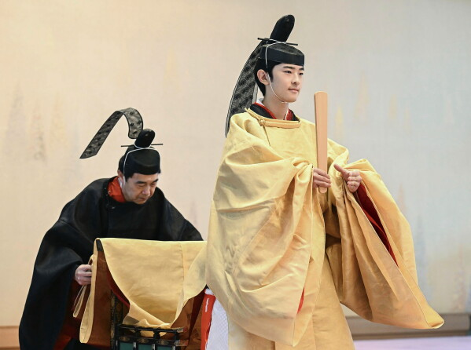
Japan’s Prince Hisahito, right, attends his coming-of-age rituals on his 19th birthday at the Imperial Palace in Tokyo, on Sept. 6, 2025. (Japan Pool/Kyodo News via AP, File)
In an imperial family that places a premium on male royal babies, Hisahito is the first such boy to be born in four decades. Only five of the 16 adults in the imperial family — there are no children — are men.
Prime Minister Sanae Takaichi and other conservatives insist the male bloodline is “the only source of the emperor’s authority and legitimacy,” which is the basis for the upcoming measures.
“I’m deeply moved,” Takaichi told reporters after the enactment.
While an emperor’s mother can be a commoner, as is the case with the current one, only boys born to men with royal blood can be heirs to the throne, according to the Imperial House Law.
The revision to the antiquated law is meant to solidify the principle of that crucial bloodline by allowing the adoption of distant royal male relatives to father future heirs, pushing the Emperor’s daughter to the side. It will also allow princesses to keep their royal status and serve duties if they marry a commoner.
“It’s a declaration to prevent female monarchs … and to defend the male lineage at all costs,” said Hideya Kawanishi, an expert on monarchy at Nagoya University. “They cannot say it’s male chauvinism, so they call it tradition.”
Imperial Household Agency chief Buichiro Kuroda said in a statement that his agency “will do everything it can appropriately to support smooth activity for the Imperial Family members in line with (the revisions), while fully taking into consideration their feelings.”

Takaichi supports male-only succession
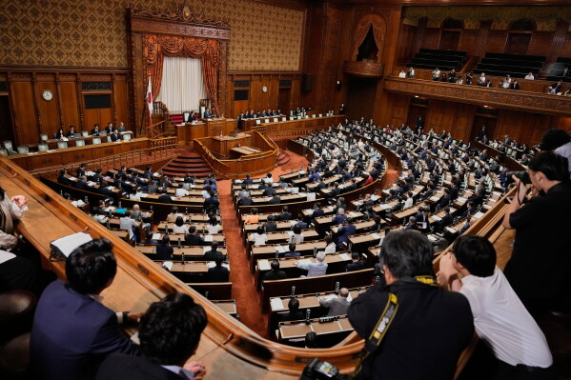
Lawmakers of Japan’s Upper House vote on a bill to revise the Imperial House Law during its plenary session in Tokyo, Friday, July 17, 2026. (AP Photo/Eugene Hoshiko)
There have been eight female monarchs. The last was Empress Gosakuramachi, who ruled from 1762 to 1770.
The paternal-line male succession was stipulated for the first time in the 1890 Imperial House Law, when Japan promoted patriarchal systems. That law was largely carried over to the current 1947 version.
Friday’s revisions have led to protests from Japanese who see the government efforts as meant to eliminate Princess Aiko from ruling and to justify discrimination against women and a patriarchal system.
“It’s very ironic that the first female prime minister herself is the leading proponent of the obsession with male succession,” Chizuko Ueno, a prominent feminist scholar, wrote recently referring to Takaichi.
Ueno said the new measures “treat male royals as stallions and put female royals under pressure as ‘childbearing machines’ to produce male offspring.”
After Aiko’s birth, her mother Empress Masako, a Harvard-educated former diplomat and a commoner, developed a stress-induced mental condition, apparently over criticism for not producing a male heir.

Imperial family is shrinking
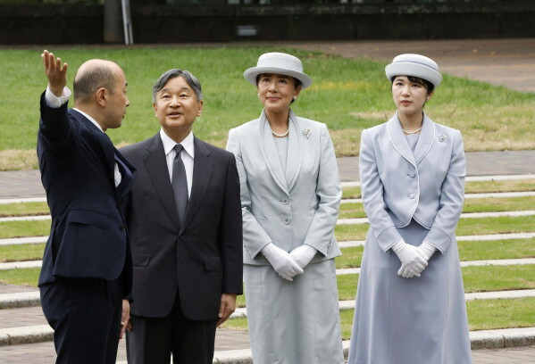
Japanese Emperor Naruhito, center left, Empress Masako center right, and Princess Aiko, right, listen to Nagasaki Mayor Shiro Suzuki as they visit the cenotaph for the atomic bombing victims at the peace park in Nagasaki. western Japan, Sept. 12, 2025. (Kyodo News via AP, File)
Because of the male-only succession rules and the dismissal of princesses who marry commoners, the monarchy after Hisahito is “extremely unstable,” former Imperial Household Agency chief Shingo Haketa told Kyodo News recently.
Historians say the current system is unworkable, as Japan more broadly faces a fast-aging, dwindling population. It only worked in the past because concubines produced half the emperors until about 100 years ago, when the practice ended under Naruhito’s great-grandfather, Emperor Taisho.
A government proposal in 2005 to allow female monarchs was scrapped following Hisahito’s birth.
Naruhito’s two male heirs are his brother, Crown Prince Akishino, 60, who is only six years younger than the emperor and has reportedly said he would be too old to serve, and Hisahito, Akishino’s 19-year-old son. Third in line is Naruhito’s uncle, Prince Hitachi, who is 90.

Distant relatives
The more controversial of the two measures allows unmarried male descendants, aged 15 or older, of distant imperial relatives — but only of paternal lineage — to be adopted into the royal family.
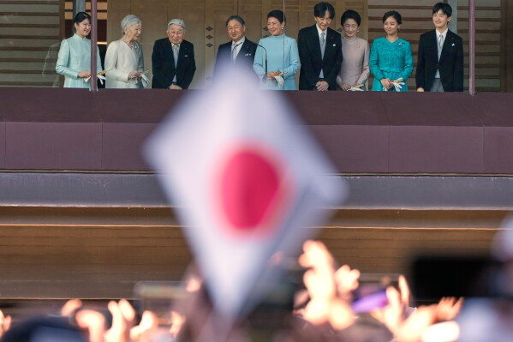
Japan’s Emperor Naruhito, fourth left, Empress Masako, fifth left, and other royal family members greet well-wishers from the balcony during a public appearance for New Year’s celebrations at the Imperial Palace, Jan. 2, 2026, in Tokyo. (AP Photo/Eugene Hoshiko, File)
Fifty-one members from 11 branch families renounced their royal status in 1947, mainly to ease the postwar financial burden on the monarchy, Imperial Household Agency official Yoshimi Ogata told a recent parliamentary session.
Those people are at least 36 generations removed from Naruhito because they split from a common male-line ancestor 600 years ago, Ogata said.
There is criticism of what some see as the government’s extraordinary efforts to make sure that male royals are producing male emperors.
“Who wants the son of an adoptee who nobody knows to be emperor instead of Aiko?” asked Yoshinori Kobayashi, a cartoonist campaigning for Aiko’s succession.
It may also be unrealistic to ask former royals to reenter a very strict family known as “an enclave without human rights.” Royals cannot choose their jobs or homes, and must follow other serious constraints.
“I wonder if anyone would raise a hand,” 81-year-old Asahiro Kuni, whose family renounced its royal status when he was 3, told TBS television. “I imagine many people, by age 15, have some idea about their future. It’s cruel to tell them … to change the course of their life.”
Kuni, who worked as an engineer at a major Japanese company, said he would tell his family to decline if asked by the palace. “You are asked to sacrifice your life for the happiness of the people. I can’t tell my family to choose such a difficult life.”
He expressed support for female monarchs in interviews with other Japanese media.

Princesses who marry commoners can keep royal status
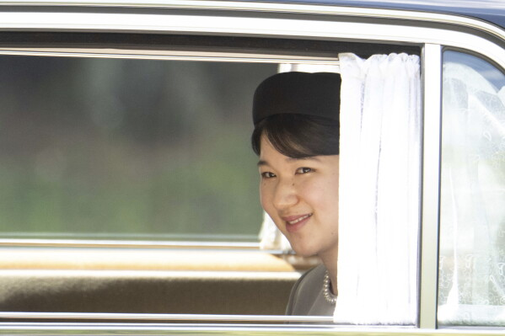
Japan’s Princess Aiko leaves after visiting the tomb of the late Empress Nagako who died in 2000, at the Musashi Imperial Graveyard in Hachioji, west of Tokyo Thursday, April 25, 2024. (Yuichi Yamazaki/Pool Photo via AP)
Aiko, known for her engaging smile, enthusiasm and witty conversation, is a public favorite.
Five single princesses, including Aiko and her popular cousin Kako, 31, may be affected by the other main revision to the Imperial House Law, which would allow them to keep their royal status and continue serving official duties if they marry commoners, although their spouse and children wouldn’t be accepted as royals.
Aiko’s elder cousin Mako renounced her royal status and moved to New York after marrying her college boyfriend, a commoner who now is a lawyer. The move was largely seen as her attempt to flee from the restrained imperial life.
Ueno calls the system inhumane and urges the princesses to follow Mako’s example and leave when they can.
Hisahito, possible adoptees and their future wives will face enormous pressure to produce male offspring, Kawanishi said.

Many Japanese want Aiko to be emperor
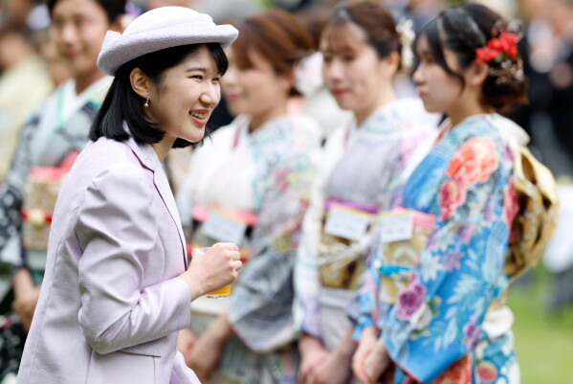
Japan’s Princess Aiko, left, daughter of Emperor Naruhito and Empress Masako, speaks with Japanese medalists of the Milan Cortina Winter Olympics during a spring imperial garden party hosted by her parents at Akasaka Palace imperial garden in Tokyo, Friday, April 17, 2026. (Franck Robichon/Pool Photo via AP)
“The emperor is a symbolic figure, and I don’t see why women cannot serve in the role,” said 78-year-old Junichiro Tsujimaru, a sushi chain founder.
Yoshio Iwase, 78, said Aiko, as the daughter of the emperor, is the legitimate successor. “I think it’s fine because there used to be female emperors in the past.”
There is worry that the government’s push will upset former Emperor Akihito’s legacy, which included making amends for the victims of World War II, fought in his father’s name.
Akihito, who abdicated in 2019, also tried to bring what was seen as an aloof monarchy closer to the people, an example followed by his son, Naruhito, and his family.
Akihito reportedly supports Aiko’s succession. He avoided directly answering a question about the 2005 government proposal but said female royals served a major role in the monarchy and that its role was to work for the happiness of the people — a remark interpreted as his support for female monarchs.
Naruhito also said in June that he hoped discussions about the measures would reach a conclusion that “will gain understanding of the people,” a comment palace watchers said was his nuanced displeasure.
Japan on Friday also enacted a controversial new law prohibiting desecration of its national flag, a key right-wing agenda pushed by Takaichi. Opponents see it as an attempt to intimidate the public and silence criticism against her government.

MARI YAMAGUCHI
Yamaguchi is based in Tokyo and covers Japanese politics, security, nuclear energy and social issues for The Associated Press.

twitter
mailto

