UNITED KINGDOM

Count Binface, the man in a can with a plan, seeks Parliament seat in Britain’s wackiest election
Binface, a self-described intergalactic space warrior, has landed in the center of the U.K.’s political universe ahead of a special election against Trump ally Nigel Farage, among others.

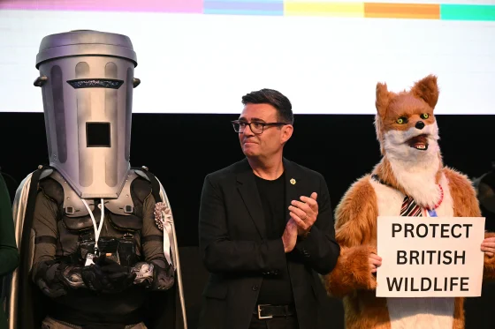
From left, Count Binface, British Prime Minister Andy Burnham and an animal welfare activist in Wigan, England, in June.Oli Scarff / AFP via Getty Images

Aug. 12, 2026, 2:00 AM MST / Source: The Associated Press
By The Associated Press
Timing is everything in comedy and, so it seems, in British politics for a perennial joke candidate who wears a garbage can on his head.
Count Binface, a self-described intergalactic space warrior, has landed in the center of the U.K.’s political universe ahead of a special election Thursday that was derided as a farce long before the ballot was packed with nearly three dozen candidates — many from the silly end of the spectrum.
Binface, who has run against prime ministers past and present, was the first to throw his bucket in the ring when Reform UK leader Nigel Farage abruptly quit Parliament and said he would seek re-election to clear his name over financial allegations.
“Game on, Nige,” Binface declared soon after Farage, portraying himself as the victim of a witch hunt, said he would represent the people against the establishment.
But when the major political parties denounced Farage’s move as a political stunt and boycotted the Clacton-on-Sea election in southeastern England, the trash-talking comedian was launched into prime position as default challenger. He has been on a nonstop media blitz since.
“I’m the only fresh thing on the menu,” Binface told The Associated Press on a day of interviews with reporters from Japan, the Netherlands, Italy and Germany. “You’re all sick of these politicians, as good as they’re trying to be, but you know you need something different, a little bit of secret sauce.”
The jokes have continued nearly nonstop — and not all are coming from the man in the can with a 20-point plan.
“If [Farage] wants to spend the summer arguing with a bin, I won’t stop him,” then-Treasury Secretary Rachel Reeves, known more for number-crunching than playing for yuks, said as she officially accepted Farage’s resignation and set the stage for the special election.

Under Binface’s black cape, rubbish bin and ample body armor that looks straight out of a low-budget sci-fi film is a middle-aged comedian named Jon Harvey trying to keep his cool during a sweaty summer.
You’d never know who was in there from talking to his alter ego. Binface never breaks character, and he delivers snarky ripostes when challenged to lift the lid.
“Has anyone here seen ‘Return of the Jedi’?” he asked a BBC host in reference to the “Star Wars” sequel in which Darth Vader is unmasked. “Nobody wants to know what’s under the recycling. ... It’s absolutely putrefying.”

YOUTUBE
https://youtu.be/T25536IrkH0?si=KsVwAe5qxelb0fXz

_from Wikipedia:
His manifesto for Clacton, launched on 27 July, included some perennial pledges, such as to build one affordable house, but he also targeted his opponent by promising to "spend more time in Clacton-on-Sea than in Washington DC"; to bar MPs who resign mid-parliament from the resulting by-election; to "not accept any £5m gifts from crypto billionaires (on Earth)".^{[86]} Seeking to represent the UK at Eurovision, he would bring the contest to Clacton in 2028 if he won.^{[87][88]} Anticipating the question of dress code in Parliament, Binface said: "If people vote Binface, they get Binface... I know there are parliamentary rules saying you can’t wear a costume. I’ll just have to change those rules."^{[7]}

^{from the New York Tiimes}
OPINIONGUEST ESSAY

Can a Man With a Trash Can on His Head Save Britain?

Text by Tanya Gold
Photographs by Harry Mitchell
Ms. Gold, who writes about British politics and culture, and Mr. Mitchell, a photographer based in London, reported from Clacton-on-Sea, England.
Aug. 11, 2026
I spent the first Saturday in August in Clacton-on-Sea, a fading seaside town on the east coast of England and the seat of Nigel Farage, the polarizing leader of the far-right Reform U.K., who was elected to Parliament in 2024, on his eighth attempt.
Children screamed with pleasure at the funfair while parents wilted in the heat. A few weeks before, in the middle of an investigation into whether Mr. Farage had broken parliamentary rules over an undisclosed gift, he announced he would resign and immediately run for re-election. The people of Clacton, he said, would be the judge of his actions.
Image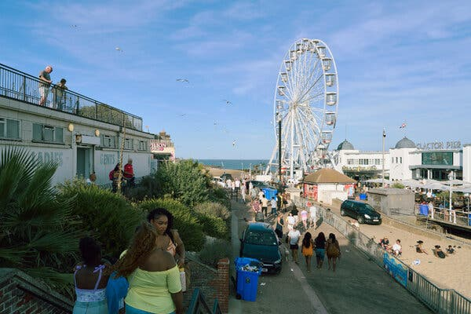
Image
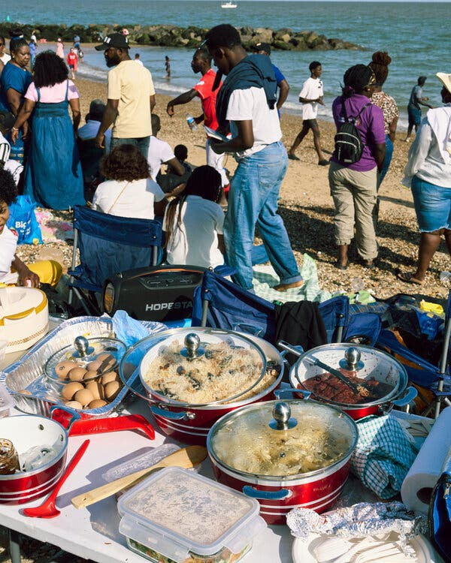
Image
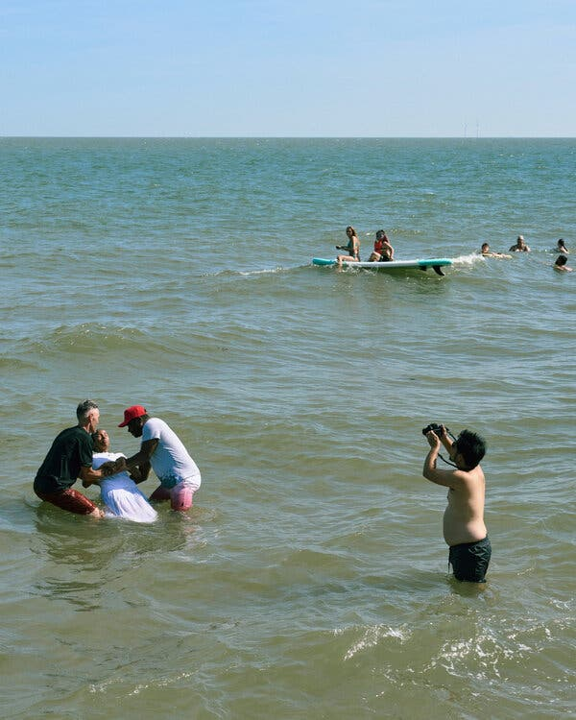
Faded grandeur is everywhere in Clacton. It is a constant reminder of the town’s past as a destination for Victorian day trippers — not least the pier, built around 1870, when Britain was the world’s superpower. Such a visible sense of the past brings the more mundane present into sharp relief and in some ways explains Reform better than any focus group.
When the present and future are frightening — and they are — people often look backward for comfort. They find it in the idea that we were great once, and that ought to mean something. Mr. Farage can eloquently voice that feeling, but he has no real solutions. In their hearts I think voters know it. We are in the weeds of culture war: It is a time of distraction.
Until recently, Reform had seemed unstoppable. It consistently polled level with or higher than the governing Labour Party — which last month, after disastrous results in local elections in which Reform made major gains — felled its leader, Keir Starmer, and replaced him with Andy Burnham as the prime minister.

Image
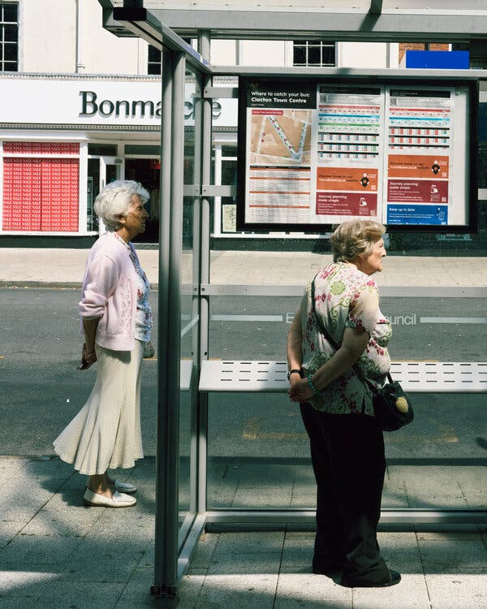
Image
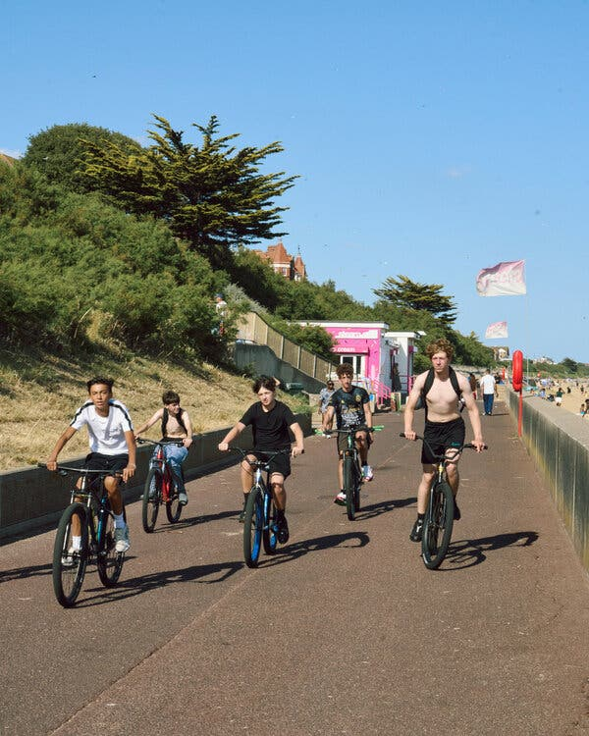
Like all insurgent parties, Reform has benefited from the major parties’ apparent inertia in the face of stagnating wages, faltering public services and scarce and expensive housing. Mr. Farage’s party blames immigration — particularly the highly visible, desperate people who cross the English Channel on small boats. (He has frequently been photographed on the Kent coast, keeping a lookout.) He was an early advocate of leaving the European Union. And though wealthy and well connected — he still dresses like the 1980s commodities trader he was — he succeeded in situating himself, like his friend President Trump, as an ally of the people against the dark forces of the global elite.
But this year something has shifted. In April, The Guardian published an investigation that described how Mr. Farage accepted a gift of about $6.7 million from Christopher Harborne, a cryptocurrency billionaire who lives in Thailand, in 2024, a couple of months before he returned as the leader of Reform. An official watchdog started an investigation the following month. The Met police is also investigating donations to the party.
Mr. Farage tried to frame these investigations as a case of the establishment versus the maverick, but this time he and the party began to slip in polls. The by-election might be understood as an attempt to take back control.
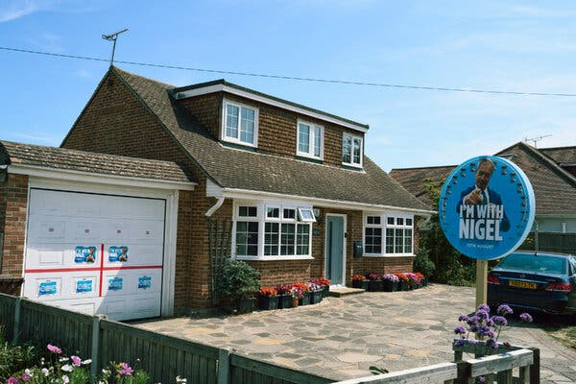
Image
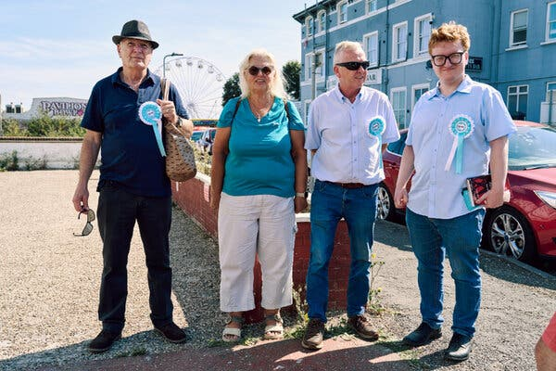
Canvassers for Reform U.K. in the party’s signature turquoise.
Image
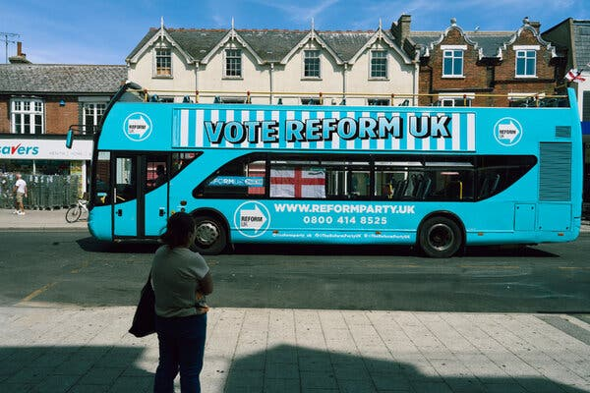
All the major parties have dismissed the election as a stunt and have declined to post candidates. Even so, there are 34 candidates on the longest and perhaps strangest ballot paper in British electoral history. There are three from the Monster Raving Loony Party, Britain’s most established novelty party: Howling Laud Hope, Nick the Incredible Flying Brick and Baron Von Thunderclap. The actor Laurence Fox, who played Hunter Biden in the 2022 movie “My Son Hunter,” is standing for his far-right party, Reclaim.
Count Binface, who says he is a 5,900-year-old intergalactic space warrior and whose policies include making arcade grabber games fairer, building at least one affordable home and promising not to accept gifts from cryptobillionaires (on Earth), is also running. The count — real name Jonathan Harvey, a comedian who studied classics at Oxford University — polled at 20 percent in late July, according to Survation.
Mr. Farage’s leading opponent is a man with a trash can on his head. Britain these days is not short of metaphor.
Image
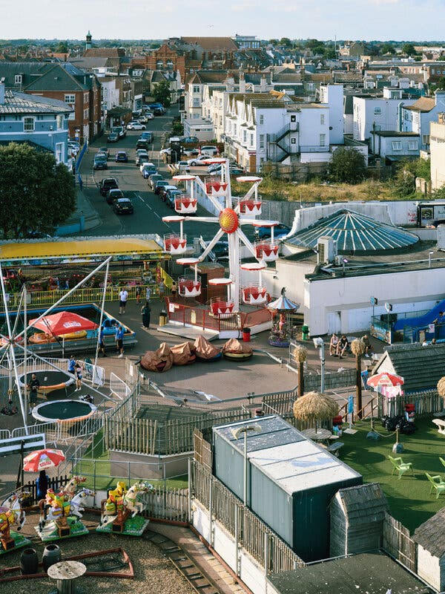
This is the 10th British by-election I have covered in seven years, and the song is always the same: alienation, ennui, despair. I met Maddie Stevens, a Clacton resident, outside a cafe near the train station. The town has “gone to rack and ruin,” she told me. “It used to be pretty and thriving,” she said. “It’s a dirty, filthy place now.”

Around lunchtime, activists for the lobby group Stand Up to Racism appeared and started handing out fliers that said “Stop Reform U.K.” and “Don’t vote Farage.” A small fight started. Pro-Farage teenagers took the “Don’t vote Farage” fliers, tore off the “don’t” and stuck the repurposed fliers untidily to a tree.

Around lunchtime, activists for the lobby group Stand Up to Racism appeared and started handing out fliers that said “Stop Reform U.K.” and “Don’t vote Farage.” A small fight started. Pro-Farage teenagers took the “Don’t vote Farage” fliers, tore off the “don’t” and stuck the repurposed fliers untidily to a tree.
This is Count Binface’s seventh political campaign, and at moments he can evoke more conventional politicians. In a campaign video, he dances by the Clacton pier and sings, “You want somebody new / Who will stand up for you / And choose hope, not fear.” He is fun, but he is a symptom of our political malaise rather than a cure.
Image
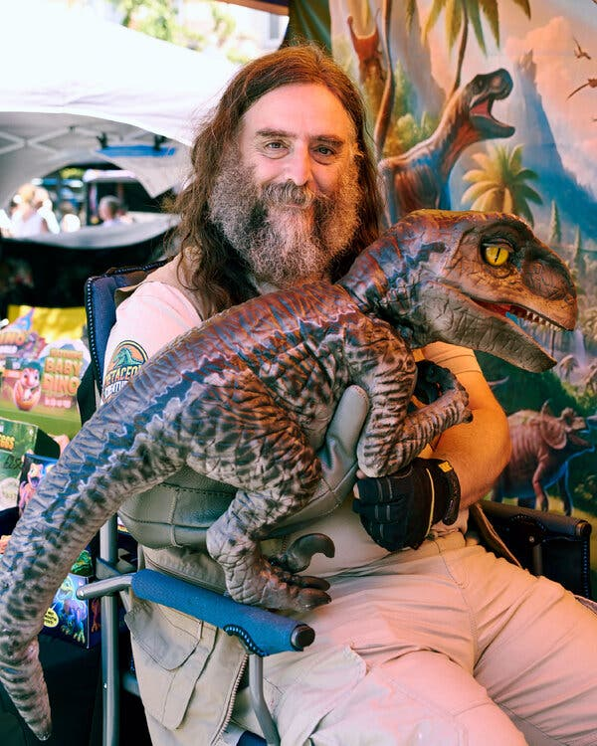
Clive Cheer, who was running a stall selling toy dinosaurs, was thrilled by Count Binface.
Image
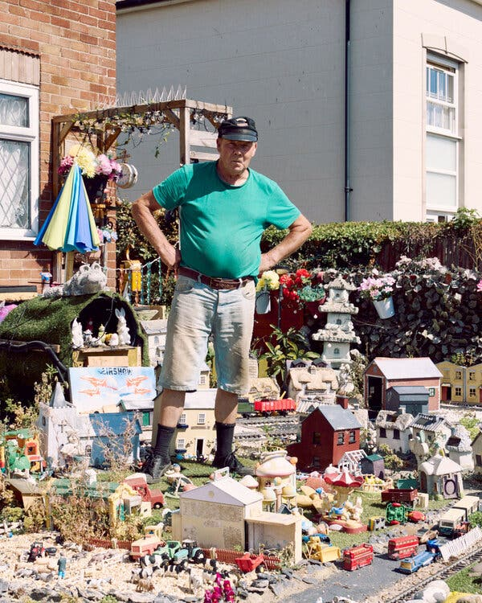
Martin Pollard, a resident of Clacton-on-Sea, in his front garden with his model village.
Nick Pelas, a theater director who also works in an apartment building for older people and is a local independent candidate, agreed. “All of a sudden, this bin man appears, and then there’s a kind of mass hysteria about him putting Clacton on the map,” he told me in a coffee shop on the town’s main street.
The way supporters of Mr. Farage were often mocked reminded Mr. Pelas of how supporters of Mr. Trump were mocked in 2016. “And people have not learned that lesson,” Mr. Pelas said. “And, God help us, what will follow?”
I watched for Mr. Farage all of that hot Saturday but didn’t see him. I left early that evening to catch a train home to Cornwall. The following day Harry Mitchell, the photographer I’d been working with, bumped into Mr. Farage at an event for veterans. He was wearing a suit and sunglasses and was surrounded by bodyguards.
Nick Pelas, a theater director who also works in an apartment building for older people and is a local independent candidate, agreed. “All of a sudden, this bin man appears, and then there’s a kind of mass hysteria about him putting Clacton on the map,” he told me in a coffee shop on the town’s main street.
The way supporters of Mr. Farage were often mocked reminded Mr. Pelas of how supporters of Mr. Trump were mocked in 2016. “And people have not learned that lesson,” Mr. Pelas said. “And, God help us, what will follow?”
I watched for Mr. Farage all of that hot Saturday but didn’t see him. I left early that evening to catch a train home to Cornwall. The following day Harry Mitchell, the photographer I’d been working with, bumped into Mr. Farage at an event for veterans. He was wearing a suit and sunglasses and was surrounded by bodyguards.
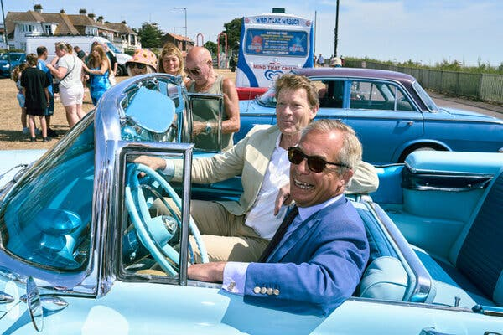
Nigel Farage, in foreground.
This is how elections are so often fought now. Politicians slink into a constituency to meet fans, make content for their social media and melt away. It’s an unserious politics for a time of decadence. And it’s not about Clacton. The election there is a proxy contest, fought with competing dreams.
Most likely, Mr. Farage will win easily on Thursday: The Survation poll had him at 73 percent. (He won 46 percent in 2024.) Then he will again face the Parliamentary Standards Commission. There could be yet another by-election in Clacton. He could run again.
But Mr. Farage will not heal Clacton — or Britain. Like the man with the trash can on his head, Mr. Farage is a symptom of our fragile, febrile times. He is here to make the most of his time in the too-hot sun.
Tanya Gold is a British journalist who writes for Harper's, The Spectator and UnHerd.

